**Preliminary Design**

Spacecraft Preliminary Design

AE-427-02

Professor: Dr. Jennifer Smith

Graduate Assistant: Matthew Willoughby

April 23, 2025

Colin Berg, Craig Dedrick, III, Liya Elan, Serena Elijah, Stephanie Ramsey

Department of Aerospace Engineering

Embry-Riddle Aeronautical University

Daytona Beach, FL, USA

**PHOCUS**

Phobos Observation and Composition Understanding System

OrbitLink

Colin Berg, Craig Dedrick III, Liya Elan, Serena Elijah, Stephanie Ramsey

April 23, 2025

The following signifies that all work within this mission design is original and completed by the following group members:

Name: Colin Berg Signature: __________________

Name: Craig Dedrick III Signature: __________________

Name: Liya Elan Signature: __________________

Name: Serena Elijah Signature: __________________

Name: Stephanie Ramsey Signature: __________________

*We, the OrbitLink Team, declare that the content of this report represents the original work of the members of our project group. This report has been prepared as part of the requirements for Spacecraft Preliminary Design, and to the best of our knowledge, it does not contain any material previously submitted for academic assessment or publication by us or any other individual, except where explicitly acknowledged.*

*We further confirm that all sources of information, data, images, and ideas borrowed from other works have been clearly cited and appropriately referenced in accordance with academic standards. We understand the importance of academic integrity and affirm that this work complies with the ethical guidelines of Embry-Riddle Aeronautical University.*

*Each group member has contributed meaningfully to the preparation of this report. We take collective responsibility for the accuracy and originality of the contents herein.*

*This page was intentionally left blank.*

Table of Contents

List of Figures 12

List of Tables 13

Nomenclature 15

i. Introduction 16

A. OrbitLink 16

B. Team Members 16

C. Team Resume 16

D. Abstract 18

ii. Mission Plan 18

A. Project Description 18

B. Importance 21

C. Similar Missions 21

D. Budget 21

E. Schedule 22

iii. Mission Objective Statement 23

iv. Mission Requirements 23

A. Overall Spacecraft System Requirements 23

B. Launch Schedule 23

v. Attitude Determination and Control 23

A. System Component Description and Masses 23

B. Moment of Inertia 24

C. Pointing Requirements 26

vi. Guidance, Navigation, and Control 26

A. System Component Description and Masses 26

B. Coordinate Systems 27

vii. Scientific Instrumentation 28

A. 8k Super Hi-Vision Cameras (Hi-Vision 8K Developed Cube Camera, NHK) 28

B. 4k Super Hi-Vision Cameras (Panasonic DMC FZ-2500) 28

C. Gamma Ray Spectrometer (Ortec Gamma Ray Spectroscopy System) 28

D. Neutron Spectrometer (SP2 Single-Sphere Neutron Spectrometer) 28

E. Mass Spectrometer (Neutral Gas and Ion Mass Spectrometer of the Mars Atmosphere and Volatile Evolution Mission) 28

F. Laser Altimeter (Advanced Scientific Concepts, GSFL-16K) 28

G. Infrared Spectrometer (HR-X Hi-Res Spectrometer) 28

H. Ultraviolet Spectrometer (BLUE-Wave Miniature Spectrometer) 29

viii. Structure 29

A. Main Structure 29

B. Internal Supports 29

C. External Supports 29

D. Landing Legs 29

ix. Propulsion 29

A. Fuel Selection 29

B. Tankage 29

C. Main Propulsion 29

D. Reaction Control and Landing Thrusters 29

x. Thermal 29

A. Thermal Design 29

B. Thermal Scenarios 30

C. Component Health 31

D. Chosen Thermal Control Systems 31

xi. Communication 33

A. Main Communication System 33

B. Tracking and Telemetry Controls System 33

C. Electra Communications 33

xii. Electric Power System 34

A. Power Production 34

B. Power Storage 34

C. Power Regulation 35

D. Power Usage 35

1. ADCS Power Usage 35

2. Internal Communication Power Usage 35

3. GNC Power Usage 35

4. Scientific Instrumentation Power Usage 35

5. Thermal Power Usage 36

6. External Communications Power Usage 36

7. EPS System Power Usage 36

8. Total Power Usage 36

xiii. Data Handling 37

A. Overall Component Data Transfer 37

B. Flight Software 38

C. Interface Control Document 38

D. Star Cameras to Computer 38

1. Interface Description 38

2. Interface Responsibilities 38

3. Coordinate Systems 38

4. Engineering Units 38

5. Mass Properties 38

6. Environment 38

7. Electrical (Power) 38

8. Electronic (Signal) 38

9. Software and Data 39

10. Error Handling 39

E. Computer to Gyroscopes 39

1. Interface Description 39

2. Interface Responsibilities 39

3. Coordinate Systems 39

4. Engineering Units 39

5. Mass Properties 39

6. Environment 39

7. Electrical (Power) 39

8. Electronic (Signal) 39

9. Software and Data 39

10. Error Handling 39

F. Laser Altimeter to Computer 40

1. Interface Description 40

2. Interface Responsibilities 40

3. Coordinate Systems 40

4. Engineering Units 40

5. Mass Properties 40

6. Environment 40

7. Electrical (Power) 40

8. Electronic (Signal) 40

9. Software and Data 40

10. Error Handling 40

G. Computer to Reaction Control Thrusters 40

1. Interface Description 40

2. Interface Responsibilities 41

3. Coordinate Systems 41

4. Engineering Units 41

5. Mass Properties 41

6. Environment 41

7. Electrical (Power) 41

8. Electronic (Signal) 41

9. Software and Data 41

10. Error Handling 41

H. Neutron Spectrometer to Computer 41

1. Interface Description 41

2. Interface Responsibilities 41

3. Coordinate Systems 41

4. Engineering Units 42

5. Mass Properties 42

6. Environment 42

7. Electrical (Power) 42

8. Electronic (Signal) 42

9. Software and Data 42

10. Error Handling 42

I. Low Gain Antenna to Computer 42

1. Interface Description 42

2. Interface Responsibilities 42

3. Coordinate Systems 42

4. Engineering Units 42

5. Mass Properties 42

6. Environment 42

7. Electrical (Power) 42

8. Electronic (Signal) 43

9. Software and Data 43

10. Error Handling 43

J. Solar Panels to Electrical Power Configuration System 43

1. Interface Description 43

2. Interface Responsibilities 43

3. Coordinate Systems 43

4. Engineering Units 43

5. Mass Properties 43

6. Environment 43

7. Electrical (Power) 43

8. Electronic (Signal) 43

9. Software and Data 43

10. Error Handling 44

K. Horizon Sensors to Computer 44

1. Interface Description 44

2. Interface Responsibilities 44

3. Coordinate Systems 44

4. Engineering Units 44

5. Mass Properties 44

6. Environment 44

7. Electrical (Power) 44

8. Electronic (Signal) 44

9. Software and Data 44

10. Error Handling 44

L. Computer to Thermal Heater 44

1. Interface Description 44

2. Interface Responsibilities 44

3. Coordinate Systems 45

4. Engineering Units 45

5. Mass Properties 45

6. Environment 45

7. Electrical (Power) 45

8. Electronic (Signal) 45

9. Software and Data 45

10. Error Handling 45

M. InfraRed Spectrometer to Computer 45

1. Interface Description 45

2. Interface Responsibilities 45

3. Coordinate Systems 45

4. Engineering Units 45

5. Mass Properties 45

6. Environment 46

7. Electrical (Power) 46

8. Electronic (Signal) 46

9. Software and Data 46

10. Error Handling 46

xiv. Launch Vehicle 46

A. Launch Vehicle Choice 46

B. Falcon 9 Properties 46

xv. Spacecraft Architecture 47

xvi. Spacecraft Component List 50

A. Attitude Determination & Control System (ADCS) 50

1. ST400 STAR TRACKER 50

2. CRS43 Gyroscopes 50

3. SSOC-A60 Sun Sensor on a Chip 51

4. Nano Avionics Reaction Wheels 51

5. Intel® Xeon® Gold 6544Y Attitude Processor 52

6. High Power Type 5-TC Solar Array Drive Assembly 53

7. C14 Bi-Axis Gimbal Communication Pointing System Actuator 53

8. Intel Xeon Gold 6248 Processor Computer 53

B. Guidance, Navigation, and Control (GNC) 54

1. Blue Canyon Technologies RW8 High Heritage Miniature Reaction Wheels 54

2. AAC Clyde Space MTQ800 High Heritage Magnetic Torquers 55

3. MEISEI Magnetometers 55

4. Servo Corporate of America Dual Array Single-Headed Earth Sensor 56

5. L3 Harris ARIES-25 Inertial Sensing 56

6. MR0-50 Safran Atomic Clocks 57

7. Advanced Scientific Concepts GSFL-16K LIDAR 57

C. Scientific Instrumentation 58

1. NHK Hi-Vision (8k) Developed Cube Camera 58

2. Panasonic DMC FZ-2500 Super Hi-Vision Camera (4k) 59

3. Ortec Gamma Ray Spectroscopy System 59

4. SP2 Single-Sphere Neutron Spectrometer 60

5. Neutral Gas and Ion Mass Spectrometer of the Mars Atmosphere and Volatile Evolution Mission 60

6. Advanced Scientific Concepts GSFL-16K Laser Altimeter 61

7. HR-X Hi-Res Spectrometer 61

8. BLUE-Wave Miniature Spectrometer 62

D. Structure 63

1. Main Bus 63

2. PHOCUS Landing Gear 63

E. Propulsion 63

1. Fuel 63

2. Tankage 63

3. MR-107B Main Reaction Control Thruster 63

4. MR-106E Reaction Control Thrusters 64

F. Thermal 64

1. Standard Passive Orbital Thermal-Control Structures Thermal Heater 64

2. Ricor K508 Stirling Cycle Cryocooler 65

3. Thermal Infrared Sensor Instrument 65

G. External Communication 65

1. Optical Communication 65

2. Low Gain Antenna 65

3. Electra System 65

H. Electrical Power System (EPS) 66

1. Roll Out Solar Arrays (ROSAs) 66

2. Lithium-Sulfur Dioxide Batteries 66

3. Power Regulation 66

xvii. Testing Requirements 66

A. Temperature Cycling 66

B. Shake and Vibration 67

C. Acoustic Testing 69

D. Shock Survivability 74

Shock Survivability 75

E. Testing 75

xviii. Insurance 77

xix. Acknowledgements 77

xx. References 78

# List of Figures

Figure 1: Block diagram of PHOCUS Mission general outline 19

Figure 2. PHOCUS development timeline 22

Figure 3: Block diagram of basic PHOCUS requirements for each spacecraft system 23

Figure 4: Preliminary 3D Model of the Spacecraft with Major Mass Components 25

Figure 5: Transfer Orbit Layout from Earth to Mars 26

Figure 6: Block diagram of general thermal design 30

Figure 7: Block diagram of active thermal design 32

Figure 8: Displays the data each component needs and gives out to other components of the spacecraft 37

Figure 9: PHOCUS on the payload mount 48

Figure 10: Drawing of the launch configuration 48

Figure 11: In space deployed configuration 49

Figure 12: Drawing of the deployed configuration 49

Figure 13: Temperature throughout launch time 67

Figure 14: Axial and lateral accelerations on the spacecraft during launching 67

Figure 15: Sinusoidal loading experienced by the spacecraft during launching at various frequencies graph 68

Figure 16: Different frequency category graph 68

Figure 17: Third octave payload acoustic data graph 69

Figure 18: Third octave payload acoustic without the use of an acoustic blanket data graph 70

Figure 19: Full octave payload acoustic data graph 73

Figure 20: Full octave payload acoustic without the use of an acoustic data blanket graph 73

Figure 21: Services offered at Kennedy Space Center 76

# List of Tables

Table 1: Spacecraft Components are Active during the Mission 20

Table 2: Initial Estimated Budget for Mission 21

Table 3: Subsystem Cost Breakdown 22

Table 4: PHOCUS Launch Schedule 23

Table 5: PHOCUS Change in Velocity 23

Table 6: Passive Control Mass Requirements 24

Table 7: Moment of Inertia Calculation 24

Table 8: Moment of Inertia Table After Solar Panel Deployment (CATIA Calculations) 25

Table 9: Moment of Inertia Table After Solar Panel Deployment (Hand Calculations) 25

Table 10: Passive Control Pointing Requirements 26

Table 11: Active Control Pointing Requirements 26

Table 12: Active Control Mass Requirements 27

Table 13: Spacecraft Temperatures through Mission Environments 31

Table 14: Coatings Chosen for Different Parts of the Spacecraft 31

Table 15: Capabilities of Active Thermal System. 32

Table 16: Gamma Ray Spectrometer System. 32

Table 17: Electra Communications Signal Values 34

Table 18: ADCS Components Power Usage 35

Table 19: Internal Communication Components Power Usage 35

Table 20: GNC Components Power Usage 35

Table 21: Scientific Instrumentation Components Power Usage 36

Table 22: Thermal Components Power Usage 36

Table 23: External Communication Components Power Usage 36

Table 24: EPS System Components Power Usage 36

Table 25: Total Power Usage 37

Table 26: Falcon 9 Capabilities Characteristics Table 47

Table 27: ST400 Star Tracker General Properties Table 50

Table 28: CRS43 Gyroscope General Properties Table 50

Table 29: SSOC-A60 Sun Sensor General Properties Table 51

Table 30: Nano Avionics General Properties Table 52

Table 31: Intel® Xeon® Gold 6544Y Processor General Properties Table 52

Table 32: High Power Type 5-TC Solar Array Drive Assembly General Properties Table 53

Table 33: C14 Bi-Axis Gimbal Communication Pointing System Actuator General Properties Table 53

Table 34: Intel Xeon Gold 6248 Processor General Properties Table 54

Table 35: Blue Canyon Technologies RW8 High Heritage Miniature Reaction Wheels General Properties Table 54

Table 36: AAC Clyde Space MTQ800 High Heritage Magnetic Torquers General Properties Table 55

Table 37: MEISEI Magnetometers General Properties Table 56

Table 38: Servo Corporate of American Dual Array Single-Headed Earth Sensor General Properties Table 56

Table 39: L3 Harris ARIES-25 Inertial Sensing General Properties Table 57

Table 40: Safran Atomic Clocks General Properties Table 57

Table 41: Advanced Scientific Concepts GSFL-16K LIDAR General Properties Table 58

Table 42: 8k Super Hi-Vision Camera General Properties Table 58

Table 43: 4k Super Hi-Vision Camera General Properties Table 59

Table 44: Gamma Ray Spectrometer General Properties Table 59

Table 45: Neutron Spectrometer General Properties Table 60

Table 46: Mass Spectrometer General Properties Table 60

Table 47: Advanced Scientific Concepts GSFL-16K LIDAR General Properties Table 61

Table 48: Infrared Spectrometer General Properties Table 62

Table 49: Ultraviolet Spectrometer General Properties Table 62

Table 50: Landing Gear Properties Table 63

Table 51: Main Reaction Control Thrusters General Properties Table 63

Table 52: Reaction Control Thrusters General Properties Table 64

Table 53: Thermal Heater General Properties Table 64

Table 54: Ricor K508 Cryocooler General Properties Table 65

Table 55: Thermal Infrared Sensor General Properties Table 65

Table 56: Solar Arrays General Properties Table 66

Table 57: Battery General Properties Table 66

Table 58: Falcon 9 Vibration Data 69

Table 59. Third Octave Payload Acoustic Data 71

Table 60. Third Octave Payload Acoustic Without the use of an Acoustic Blanket Data 72

Table 61: Full Octave Payload Acoustic Data 74

Table 62: Full Octave Payload Acoustic Without the Use of an Acoustic Blanket Data 74

Table 63: Shock Response Data 74

Table 64: Shock Response Data 75

# Nomenclature

ADCS Attitude Determination Control System

AE Aerospace Engineering

Al Aluminum

AR Aspect Ratio

BCT Blue Canyon Technologies

BPSK Binary Phase Shift Keying

CCD Critical Command Decoder

DAQ Data Acquisition

DC Direct Current

DSN Deep Space Network

FEC Forward Error Correction

FOV Field of View

GEV General Environmental Verification Standard

GNC Guidance, Navigation, and Control

GRS Gamma Ray Spectrometer

ICD Interface Control Document

ICRS International Celestial Reference System

ID Identification Document

IR Infrared Radiation

JAXA Japanese Aerospace Exploration

LETF Launch Equipment Test Facility

LOX Liquid Oxygen

MMX Martians Moon Exploration

NAIF The Navigation and Ancillary Information Facility

NASA National Aeronautics and Space Administration

OQPSK Offset Quadrature Phase Shift Keying

PM Phase Modulation

PHOCUS Phobos Observation and Composition Understanding System

QPSK Quadrature Phase Shift Keying

ROSA Roll Out Solar Array

RP-1 Rocket Grade Kerosene

RS Recommended Standard

SPICE Spacecraft, Planet, Instrument, C-matric, Events

SRAM Static Random-Access Memory

STK Systems Tool Kit

TRL Technology Readiness Level

USD United States Dollars

VDC Volts Direct Current

# Introduction

## A. OrbitLink

OrbitLink aims to secure funding for the mission PHOCUS (Phobos Observation and Composition Understanding System). PHOCUS will send a spacecraft orbiter and lander to Phobos and gather data about Phobos’s material composition and topography as well as gather data about Mars’s topography from the perspective of Phobos. OrbitLink aims to deliver high-quality research and solutions to the future exploration of Mars. With a strong focus on future innovation, OrbitLink strives to achieve mission goals through a forward-thinking approach. Founded in 2025, the OrbitLink team is composed of diverse individuals who bring unique ways of thinking and a different sets of skills to solve problems and forward humanities progress towards interplanetary colonization.

The OrbitLink team is composed of five team members: Colin Berg, Craig Dedrick III, Liya Elan, Serena Elijah, and Stephanie Ramsey. PHOCUS will be the first mission completed by the OrbitLink team.

## B. Team Members

The following is a description of all team members, including project experience and skills

1. Colin Berg
   1. Works on Project Artemis-ERFSEDS and SPICE toolkit project
   2. Technical skills in MATLAB, Excel Formulas, CATIA, and Open Rocket
2. Craig Dedrick III
   1. Works on Project Zephyr-ERFSEDS and Orbital Determination Project
   2. Technical skills in MATLAB, Soldering, Excel, and CATIA
3. Liya Elan
   1. Works on Project Spacesuit Thermal and Radiation Shielding Assessment, the Effect of Vehicle Profile on Drag, KBR Axiom Space Mission, Aircraft Design Project, and the Effect of Amorphous Carbon on Hydrogen Fuel Storage Cells Experiment
   2. Technical skills in MATLAB, CATIA, Fusion360 AutoCad, SolidWorks, Microsoft Productivity Software, and Inkscape
4. Serena Elijah
   1. Works on Complexity Index of Cislunar Missions Project, Supersonic Rocket Project, and ode45 Spacecraft Attitude Dynamics
   2. Technical skills in Python, MATLAB, Google Workspace, CATIA v5, Pointwise, and Microsoft Suite
5. Stephanie Ramsey
   1. Works on the Restricted Three Body Problem, Paramotor Project, and Antenna Design
   2. Technical skills in STK, MATLAB, SolidWorks, CATIA, Cura, CST, and Soldering

## C. Team Resume

**OrbitLink**

**Daytona Beach, Fl | 704-795-8708 | dedricc1@my.erau.edu**

**Colin Berg, Craig Dedrick, Liya Elan, Serena Elijah, Stephanie Ramsey**

_____________________________________________________________________________________________

**Education**

**4x Embry Riddle Aeronautical University, B.S. 2025**

Major: Aerospace Engineering | Minor: Physics, Applied Mathematics

**Work Experience**

**KBR | Research and Missions Integration and Opts Intern (****KBR) 2024**

* Worked with the KBR Axiom joint venture with NASA to develop the AxEMU Suit
* Worked on developing warning messages and an interactive systems guide for the AxEMU Suit
* Recorded demo videos for AxEMU Suit and Tools while also designing a suit stand for the Prada suit

**Penn State University | Research and Development Intern Engineer  2024**

* Designed an antenna to resonate within a certain frequency range using CST
* Obtained a security clearance

**Penn State University | Research and Development Intern Engineer  2023**

* Designed a venturi mount for a paramotor within the Penn State University drone laboratory

**HUB International | Sales Associate Intern  2023**

* Collaborated with top producers in Southeast
* Created Sale Presentations
* Completed projects to facilitate the sales process

**Project Experience**

**Project Zephyr ERFSEDS Project**   **2024 - Present**

* Designed and created a safer, more efficient, cost-effective, and compact recovery system able to withstand supersonic forces
* Designed and constructed the vehicle to house and test the experimental recovery system

**Space Suit Thermal and Radiation Shielding Assessment  2024**

* Assessed the thermal and radiation shielding in the Shuttle and Apollo EMU suits
* Researched and assessed better EPG material for thermal shielding
* Assessed the radiation shielding of the EPG material

**Restricted Three-Body Problem Research Project 2024**

* Numerically propagated the circular restricted three-body problem in ode45
* Computed the Jacobi constant for each moment in time
* Plotted Halo, Axial, and Butterfly Orbits while showing the location of the Lagrange points through MATLAB calculations

**Fingerprint Analysis Database 2024**

* Created MATLAB code that used the theory of fingerprint identification through eigenvalues and eigenvectors to match fingerprint images with previously stored images using biometrics

**Project Acme ERFSEDS Project 2023 - Present**

* Supported ERFSEDS projects by manufacturing requested fiberglass or carbon composite parts
* Created parts using X-Winder or by hand and upholding rigorous safety procedures
* Utilized hands-on technical skills and refining procedures to improve part quality and save cost

**Artemis ERFSEDS Project 2023 - Present**

* Provided hands on support manufacturing and drilling, club made body tubes and applied layup tip-to-tips
* Used CATIA and OpenRocket to computer model an IREC competition rocket designed by mission leads
* Designed fin test stands to certify fin and fillet design

**Orbital Determination Project 2023**

* Utilized MATLAB for positional tracking of an object in orbit using two body motion and orbital elements

**UV Self Cleaning Water Bottle 2022**

* Created individual models of each part of the water bottle
* Created title blocks for certain pieces of the water bottle
* Created a top and bottom assembly with assembly title blocks

**Aircraft Design Project 2021**

* Designed an aircraft that could carry four satellites for long distances

**Modeling RC Helicopter 2021**

* Executed the individual part modeling, engineering drawings, and assembly of modeled parts of an RC helicopter through CATIA 3D modeling software

**The Effect of Amorphous Carbon on Hydrogen Fuel Storage Cells 2021**

* Tested how amorphous carbon, created from sugar and sulfuric acid, would affect the safety and efficiency of hydrogen fuel in hydrogen fuel storage cells.

**The Effect of Air Pressure on Alpha and Beta Particles**   **2018 - 2019**

* Tested how different air pressures would affect the distance traveled by alpha and beta particles
* Created the air pressure chamber for experiment

**Skills & Abilities**

• STK Certified (Levels 1 & 2) • MATLAB • SOLIDWORKS • CATIA V5

• Fusion 360 AutoCAD • Inkscape • Microsoft Word • Microsoft PowerPoint

• Microsoft •Excel • Microsoft Access • Cura Proficiency

• CST Proficiency • Soldering

**Extracurricular Activities**

• Women’s Basketball • Men’s Track (Sprint Team Captain) • Honors Program

• Tau Beta Pi • Eaglenauts • ADAMUS Research Lab

• ERFSEDS (Embry Riddle Future Space Explorers and Developers Society)

## D. Abstract

The exploration of Mars has been a key focus for space missions as there is high potential for scientific discovery and interplanetary colonization to further the human race. One idea is to gather information and resources from Mars’s moons to aid in future missions to Mars. The Martian moon Phobos shows the most promise when it comes to providing material resources and valuable research for Mars colonization. A previous mission attempted for this purpose was the Phobos-Grunt mission by Russia. This mission resulted in failure as thrusters were not activated at the proper time, causing the spacecraft to be stranded in Earth’s orbit. Another mission, Martian Moons Exploration, will be attempted in the future by the Japanese Aerospace Exploration Industry to explore both Phobos and Deimos; however, it is not expected to launch until 2026. The objective of PHOCUS is to launch, orbit, and land a spacecraft on the Martian moon, Phobos. This mission is designed to map the topography of Phobos’s surface and analyze its material composition. This will be used to determine if Phobos has resources that could support a future Martian colony. Locating resources on a location closer to Mars will mitigate unnecessary costs for material shipping for future missions or projects. The mission is set to launch from Earth on January 5th, 2029 at 1:00 a.m. and will be in transit to Mars for 233 days. The spacecraft will arrive at Mars on August 26th 2029 at 1:00 a.m. The spacecraft will orbit Mars for two days, then depart for Phobos on August 28th, 2029 at 1:00 a.m. The spacecraft will arrive at Phobos’s orbit on September 7th, 2029 at 1:00 a.m. The spacecraft will land on Phobos in 2037 and will carry out its mission operations until 2039. Subsystems included are the Attitude Determination and Control System, Guidance, Navigation, and Control System, Scientific Instrumentation, Structure, Propulsion, Thermal, Communication, Power System, and Data Handling. It is estimated that the mission will cost 625 million USD and will take an estimated total of ten years to complete.

# Mission Plan

## A. Project Description

PHOCUS is a sampling mission of the Martian moon Phobos designed by the OrbitLink team. The spacecraft will be built and tested in-house. Scheduled for launch around early 2029, the spacecraft will depart Earth after being sent fully on its way to Mars by a procured launch vehicle then deploy its solar arrays for the approximately 200-day journey. Once it arrives, the spacecraft will capture into a highly elliptical orbit around Mars then steadily drop into a quasi-stable orbit around Phobos. The spacecraft will start a planned seven years first phase of operations taking measurements and pictures of both Phobos and Mars. The cameras will also generate a high-quality map of the surface and find the ultimate landing site needed during the second phase of operations. During the second phase of operations, the spacecraft will land on the surface and continue to operate for a planned three years, analyzing a collected sample with its on-board instruments. It will also continue using its cameras to provide surface pictures. During both phases, the spacecraft will communicate with the Mars relay network and provide support to other missions. PHOCUS seeks to understand the material composition and topography of Phobos, to understand its formation history, and to find promising sites to extract water ice for both fuel and drinking water for future human exploration. PHOCUS will be a scientifically valuable mission that can support the continued exploration of the Red Planet.

An outline of this mission is shown through Figure 1 in a block diagram.

Figure 1: Block diagram of PHOCUS Mission general outline

Table 1: Spacecraft Components are Active During the Mission

|  |  |  |  |  |  |
| --- | --- | --- | --- | --- | --- |
| **Component** | **Launch** | **Transit to Phobos Orbit** | **Orbiting Phobos** | **Landing on Phobos** | **Obtaining Data from Phobos** |
| Star Cameras | Active | Active | Active | Active | Inactive |
| Gyroscopes | Inactive | Active | Active | Active | Active |
| Sun Sensors | Inactive | Active | Active | Active | Inactive |
| Reaction Wheels | Inactive | Active | Active | Active | Inactive |
| Attitude Processors | Inactive | Active | Active | Active | Active |
| Intel Xeon Gold 6248 Processor | Active | Active | Active | Active | Active |
| Landing Gear | Inactive | Inactive | Inactive | Active | Inactive |
| High Heritage Miniature Reaction Wheels [BCT] | Active | Active | Active | Active | Inactive |
| High Heritage Magnetic Torquers | Active | Active | Active | Active | Inactive |
| Magnetometers | Inactive | Inactive | Active | Active | Active |
| Horizon Sensors | Inactive | Inactive | Active | Active | Inactive |
| Inertial Sensing | Active | Active | Active | Active | Active |
| Deep Space Navigation | Active | Active | Active | Active | Active |
| Atomic Clocks | Active | Active | Active | Active | Active |
| Lidar | Inactive | Inactive | Active | Active | Inactive |
| Super Hi-Vision Cameras (8k) | Inactive | Inactive | Active | Active | Active |
| Super Hi-Vision Cameras (4k) | Inactive | Inactive | Active | Active | Active |
| Gamma Ray Spectrometer | Inactive | Inactive | Active | Inactive | Inactive |
| Neutron Spectrometer | Inactive | Inactive | Active | Inactive | Inactive |
| Mass Spectrometer | Inactive | Inactive | Active | Inactive | Inactive |
| Laser Altimeter | Inactive | Inactive | Active | Active | Inactive |
| InfraRed Spectrometer | Inactive | Inactive | Active | Inactive | Inactive |
| Ultraviolet Spectrograph | Inactive | Inactive | Active | Inactive | Active |
| Thermal Heater | Active | Active | Active | Active | Active |
| Thermal Pumps | Active | Active | Active | Active | Active |
| Thermal Infrared Sensor | Active | Active | Active | Active | Active |
| Optical communication | Inactive | Active | Active | Active | Active |
| Low Gain Antennas | Active | Active | Active | Active | Active |
| Electra System | Inactive | Inactive | Active | Active | Active |
| Power Distribution | Active | Active | Active | Active | Active |
| Power Regulation and Control | Active | Active | Active | Active | Active |

## B. Importance

As humans begin the new age of space exploration and look to become interplanetary, the establishment of a permanent Martian colony is unavoidable. To ensure the survival and self-sustainability of a Martian colony, certain resources will need to be readily available as development progresses. The primary resources needed include water and air, which have been found through previous missions to Mars. In addition, to turn a Martian base into a Martian colony, resources such as glass, plastic, cement, and metals will also be needed to help the colony develop an infrastructure. Depending on the location of the colony, these may not be readily available on Mars itself and would need to be obtained from elsewhere. The PHOCUS mission will determine the general makeup of Phobos to see if it is a viable option to obtain such resources, which include deposits of metals, sand, or carbonates to produce steel, glass, and cement, which will be crucial in developing the colony. The shipment of such materials from Earth may be possible in the beginning stages, however, the shipment of such materials over time for the expansion of the colony is not economically effective. If the acquisition of these resources is not economically feasible, then the colony will not be sustainable in the long term.

## C. Similar Missions

The following missions were either attempted or are in progress. These missions include collecting samples from the moon, Phobos.

1. Martians Moons Exploration (MMX)
   1. This is a future mission being completed by JAXA, the Japan Aerospace Exploration Agency, that is intended to launch in 2026 to retrieve samples from Phobos to understand its origin, leading to a better understanding of the formation of the solar system.
2. Phobos-Grunt
   1. This is a failed mission that was attempted by Russia that attempted to extract and return samples from Phobos. The thrusters did not burn at the scheduled time to reach the trajectory to Mars, causing the spacecraft to be stranded in Low Earth Orbit and eventually burnt into the Earth’s atmosphere.

## D. Budget

The estimated budget for the mission is 625 million USD, split among the categories shown below in Table 2 and broken down even further in Table 3.

Table 2: Initial Estimated Budget for Mission

|  |  |  |
| --- | --- | --- |
| **Category** | **Cost (in million USD)** | **Percent of Budget** |
| Preliminary Design​ | 1​ | 0.16%​ |
| Critical Design​ | 5​ | 0.8%​ |
| Labor (Manufacturing and management)​ | 80​ | 12.8%​ |
| Facility Costs (3-year build time)​ | 9​ | 1.44%​ |
| Spacecraft Bus + Instruments​ | 220​ | 35.2%​ |
| Testing costs (~30 % of material cost)​ | 60​ | 9.6%​ |
| Launch Services (Mainly launch cost)​ | 80​ | 12.8%​ |
| Overrun Provisions (Supplier delays)​ | 40​ | 6.4%​ |
| Operations (~30 people and DSN costs across 8 years)​ | 130​ | 20.8%​ |
| Total Cost:​ | 625​ | 100%​ |

Table 3: Subsystem Cost Breakdown

|  |  |  |
| --- | --- | --- |
| **Category​** | **Cost (in million USD)​** | **Percent of Category** |
| ADCS​ | 36.4​ | 16.55% |
| Landing System (Gear/ Laser Altimeter)​ | 4.7​ | 2.14% |
| GNC​ | 22.0​ | 10.00% |
| Scientific Instrumentation​ | 53.2​ | 24.18% |
| Structure​ | 33.6​ | 15.27% |
| Thermal Control​ | 12.7​ | 5.77% |
| External Communications​ | 19.4​ | 8.82% |
| Power Generation & Regulation​ | 21.3​ | 9.68% |
| Propulsion (Monopropellant)​ | 16.7​ | 7.59% |
| Total Subsystem Cost:​ | 220​ | 100% |

## E. Schedule

The following is a tentative timeline for mission development and operations, expected to take about five years in design, building, testing, and launch, and about ten years of mission operations.

Concept Development and Funding:

* Preliminary Design: 6 months
* Critical Design: 14 months
* Funding: Overlapped significantly

Construction and Testing:

* Construction of the Spacecraft: 18 months
* Testing of the Spacecraft: 8 months

Launch and Arrival:

* Transit and processing: 1 month
* Arrival Time: ~8 months
* Commissioning Time: ~2 months
* Orbiting Photos: 7 years

Landing:

* Sample Collection: Immediately upon landing
* Surface Operations: 3 years

Figure 2. PHOCUS development timeline

# Mission Objective Statement

Our mission is to traverse, orbit, and land a spacecraft on Phobos to gather data about Phobos’s topography and surface material make up as well as gather more information on Mars’s topography; this is to see if Phobos has resources that can be used for Martian colonization in future missions.

# Mission Requirements

## A. Overall Spacecraft System Requirements

The basic mission requirements for each of the spacecraft systems are outlined in a block diagram shown in Figure 3.

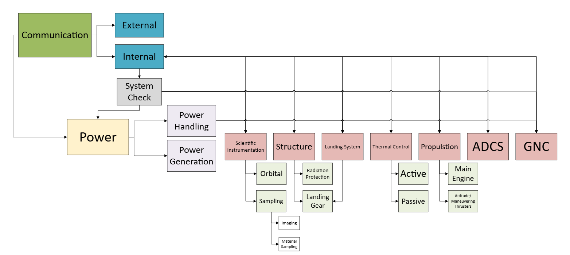

Figure 3: Block diagram of basic PHOCUS requirements for each spacecraft system

## B. Launch Schedule

The PHOCUS launch schedule is outlined in Table 4 and Table 5.

Table 4: PHOCUS Launch Schedule

|  |  |  |  |  |  |  |
| --- | --- | --- | --- | --- | --- | --- |
| **Departing Location** | **Departing Date** | **Departing Time** | **Flight Duration** | **Arriving Location** | **Arriving Date** | **Arriving Time** |
| Earth | January 5th, 2029 | 1:00 a.m. | 233 days | Mars | August 26th, 2029 | 1:00 a.m. |
| Mars | August 28th, 2029 | 1:00 a.m. | 10 days | Phobos | September 7th, 2029 | 1:00 a.m. |

Table 5: PHOCUS Change in Velocity

|  |  |  |  |  |
| --- | --- | --- | --- | --- |
| **Departing Location** | **Arriving Location** | **Initial Change in Velocity** | **Final Change in Velocity** | **Total Change in Velocity** |
| Earth | Mars | 2975.87 m/s | 791.11 m/s | 3766.99 m/s |
| Mars | Phobos | 19.15 m/s | 2184 m/s | 2203/91 m/s |

# Attitude Determination and Control

## A. System Component Description and Masses

Star Cameras (AAC Clyde Space – ST200) – A star camera is a camera that has high measurement accuracy, a small field of view, and long focal length. They have the advantage of high accuracy, light mass, lower power consumption, no drift, and multiple operating models. However, due to periodic variations in solar radiation, there is temperature fluctuation, which also affects the measurement accuracy of the optical system. The star cameras are used to capture images, process the signals captured by the optics, execute algorithms that identify and compare the observed stars with a star database, and determine the spacecraft’s orientation based on the relative position of the observed stars.

Gyroscopes (VSG Thin Film PZT vibrating ring sensor technology in a CRS03-like F3 module)- Gyroscopes are used for attitude control, navigation, and spacecraft maneuvers. They are designed to withstand high temperatures, vibrations, and accelerations, which makes them suitable for the PHOCUS mission. The selected gyroscope delivers high performance motion sensing, even under severe shock and vibration.

Sun Sensors (SSOC-A60 Analog interface) – The purpose of sun sensors is to determine the orientation of the sun with respect to a reference coordinate system in the spacecraft. This is done by detecting the intensity difference between radiation observed at a solid angle from the Sun’s boundaries and radiation observed from adjacent regions in the sensor’s field of view. This helps with determining where the sun is with respect to the spacecraft and will be used to determine the orientation and position of the spacecraft as it traverses from Earth to Phobos.

Reaction Wheels (Nano Avionics) – The purpose of reaction wheels is to create torque in the spacecraft to ensure that its orientation is within the appropriate parameters. Data from instruments, such as the sun sensors, will send information on the orientation and location of the spacecraft to the attitude processors. The attitude processors will determine if the spacecraft is within tolerance of the orientation it should be in and send signals to the reaction wheels to align the spacecraft’s orientation back to the acceptable parameters while traversing to Phobos.

Attitude Processors (Intel® Xeon® Gold 6544Y Processor)– The attitude processor is the attitude determination and control software; this component is designed to control the attitude of the spacecraft. The chosen attitude processor provides high-performance computing for space Attitude Determination and Control Systems (ADCS). Its multi-core architecture handles complex algorithms for real-time sensor data processing, attitude calculations, and control commands. Its reliability and power efficiency make it suitable for demanding space missions, ensuring precise spacecraft orientation and stability in space environments.

Table 6: Passive Control Mass Requirements

|  |  |
| --- | --- |
| **Passive** | **Mass (kg)** |
| Star Camera | 0.085 |
| Gyroscopes | 0.000050 |
| Sun Sensors | 0.025 |
| Reaction Wheels (4RWO) | 0.76 |
| Attitude Processors | ~ 0 |

## B. Moment of Inertia

Preliminary values for the moment of inertia of the spacecraft were found using a combination of 3D modeling and hand calculations. The largest mass spacecraft systems were considered such as the structure, the fuel tank and fuel, as well as the solar panels. The 3D modeling was done in Catia based off mainly referencing specific components, such as the ROSA and low mass aluminum honeycomb for the main bus. The hand calculations were made by assuming each component is either a cuboid or a sphere of constant density, as well as using a general rigid body moment of inertia matrix.

Table 7: Moment of Inertia Calculation

|  |  |
| --- | --- |
| **Name** | **Mass** |
| Main Bus (Al honeycomb 25 mm thickness) | 38.5 kg |
| 2 Roll Out Solar Arrays | 110.68 kg |
| Hydrazine Tank (Al 6 mm thickness) | 135.83 kg |
| Hydrazine Fuel | 2780 kg |

The moment of inertia matrix presented is representative of the spacecraft just after solar panel deployment after the trans-Martian injection from the launch vehicles second stage. This is when the spacecraft will be the heaviest and every part deployed to its furthest extent. The axis has an origin at the center of mass, with the y axis along the axis tip to tip through the solar panels, and the z-axis coincident with the upper walls normal vector.

Table 8: Moment of Inertia Table After Solar Panel Deployment (CATIA Calculations)

|  |  |
| --- | --- |
| **Inertial Axis** | **Inertia (kg*m3)** |
| Ixx | 8159.86 |
| Iyy | 1055.81 |
| Izz | 8218.10 |
| Ixy | 12.46 |
| Iyz | 0 |
| Ixz | 0 |

Table 9: Moment of Inertia Table After Solar Panel Deployment (Hand Calculations)

|  |  |
| --- | --- |
| **Inertial Axis** | **Inertia (kg*m3)** |
| Ixx | 8430.23 |
| Iyy | 1016.88 |
| Izz | 8338.05 |
| Ixy | 0 |
| Iyz | 0 |
| Ixz | 0 |

Figure 4: Preliminary 3D Model of the Spacecraft with Major Mass Components

## C. Pointing Requirements

Figure 5: Transfer Orbit Layout from Earth to Mars

The spacecraft will transit from Earth to Mars using a Hohmann transfer that will take 233 days. The spacecraft is set to launch on January 5th, 2029, at one in the morning, and will arrive to Mars on August 26, 2029, at one in the morning. From there, the spacecraft will enter a circular orbit around Mars for approximately two days, then utilize another Hohmann transfer to reach Phobos that should take approximately ten days. The spacecraft will depart from Mars on August 28th, 2029, at one in the morning, and will arrive at Phobos August 28th, 2029, at one in the morning. This orbit path along with the component requirements were used to determine the direction each of the components needed to point during orbit and transit.

Table 10: Passive Control Pointing Requirements

|  |  |
| --- | --- |
| **Passive** | **Pointing Requirements** |
| Star Camera | Star cameras cover entirety of the spacecraft |
| Sun Sensors | Sun sensors cover entirety of the spacecraft |

Table 11: Active Control Pointing Requirements

|  |  |  |
| --- | --- | --- |
| **Active** | **Target Requirements** | **Radian Requirements** |
| Magnetometers | In the direction of the magnetic field being measured | 17.5 mrad |
| Horizon Sensors | Towards the edge of the planet’s atmosphere | 0.143 rad |
| Optical Communication | Towards the communication antenna located on Earth | 4 mrad |
| Solar Panel Actuators | Towards the sun | 0.35 rad to minimize actuator use |
| LIDAR | Towards the body of interest | 26.18 mrad |

# Guidance, Navigation, and Control

## A. System Component Description and Masses

High Heritage Miniature Reaction Wheels (Blue Canyon Technologies, RW8) - The design of this instrument includes a brushless DC motor, ultra-smooth bearings, and an advanced lubrication system which ensures low jitter performance and a long mission life. Due to its design, it would provide a high accuracy observer-based control design and a high torque-to-speed ratio.

High Heritage Magnetic Torquers (AAC Clyde Space, MTQ800) – These will provide control torques perpendicular to the local external magnetic field. This will be used to orient the spacecraft within the acceptable parameters while orbiting Phobos.

Magnetometers (MEISEI) – This is a highly sensitive instrument used to measure magnetic fields for information on how to navigate and orient the spacecraft.

Horizon Sensors (Servo Corporation of America, Dual Array Single-Headed Earth Sensor) - The Horizon Sensors utilize a mirror, lens, and infrared sensor to determine the horizon of a celestial object relative to the spacecraft for information on how to orient the spacecraft.

Inertial Sensing (L3 Harris, ARIES-25) – Inertial Sensing uses gyroscopes and accelerometers to measure angular velocity and linear acceleration to determine the past and current position of the spacecraft. Small errors referred to as drift can accumulate over time and therefore must be accompanied by other systems.

Deep Space Navigation (General Dynamics, Small Deep Space Transponder) – Deep Space Navigation utilizes radio signals, optical tracking, and celestial navigation for tracking the position of the spacecraft and calculating spacecraft trajectory. This is accomplished through measuring frequency shift or delays in signals sent back to Earth and by using cameras to track celestial objects around the spacecraft to determine the position of the spacecraft relative to those bodies.

Atomic Clocks (Safran) – These are extremely precise clocks that keep time using the vibrations of atoms. They measure the time delay in communication signals and allow for one way ranging so tracking from Earth is not as heavily weighted for spacecraft positional tracking. This is important for making real time course corrections.

LIDAR (Advanced Scientific Concepts, GSFL-16K) – LIDAR uses a laser to measure the distance to nearby objects by timing the reflection of the light pulses. This allows for specific distances from objects to be measured and can be used in mapping terrain on landing or to allow assistance in docking with another spacecraft. This system works similarly to radar, but with a much higher precision.

Solar Arrays Drive Actuator (High Power Type 5-TC Solar Array Drive Assembly) – This device allows control of the orientation of the solar panels to ensure they are pointing in the optimal direction. They have a 150-degree range in either direction and have optimal operational temperatures and power output for our mission requirements.

Communication Pointing System Actuator (C14 Bi-Axis Gimbal) – This is a device that allows control over the pointing direction of our external communication system. It is well within our operational temperature range and is initially designed for pointing communication equipment such as antennas, which will be its primary function for our mission.

Table 12: Active Control Mass Requirements

|  |  |
| --- | --- |
| **Active** | **Mass (kg)** |
| High Heritage Miniature Reaction Wheels {BCT, RW8} | 1.1 |
| High Heritage Magnetic Torquers | 0.395 |
| Magnetometers | 0.22 |
| Horizon Sensors | 0.00035 |
| Inertial sensing | 0.2 |
| Deep Space Navigation | 3.2 |
| Atomic Clocks | 0.075 |
| LIDAR | 3.2 |

## B. Coordinate Systems

There are three coordinate systems used for Guidance, Navigation, and Control.

The first is the Celestial Reference System, which has the origin at the point where the gravitational pull of all bodies in the solar system are balanced. The axes are defined as “space fixed,” which means they are not rotating. This coordinate system provides an accurate way to describe the location of celestial objects, which includes stars, planets, and satellites.

Other coordinate systems include the IAU_PHOBOS and the IAU_MARS. These are provided by the NAIF Spice toolkit. These are both inertial references frames with the origin being at the center of Phobos and Mars, respectively. These coordinate systems are used when analyzing the parameters specifically associated with either Phobos or Mars.

# Scientific Instrumentation

## A. 8k Super Hi-Vision Cameras (Hi-Vision 8K Developed Cube Camera, NHK)

These cameras provide high resolution imaging that will be utilized in mapping the topography and surface environments of Phobos. This information will prove critical in determining the landing location of the spacecraft on the surface of Phobos. Two cameras will be used to carry this mission out with 120 frames per second capture speed. An alternative use to these high-resolution cameras will be taking images of the surface of Mars as well observing the topography to gain insight on potential landing sites for the first Martian mission.

## B. 4k Super Hi-Vision Cameras (Panasonic DMC FZ-2500)

These cameras provide high resolution imaging which will be utilized in determining the topography and surface environment of Phobos. These cameras have half of the resolution as 8k Super Hi-Vision cameras and therefore will be utilized more for closer range imaging or once the spacecraft has landed.

## C. Gamma Ray Spectrometer (Ortec Gamma Ray Spectroscopy System)

This component will utilize cosmic gamma rays bouncing off the surface of Phobos to determine the material composition of what the rays are being bounced from. This allows for the identification of pockets of solid water, carbonates, or metals, which is the objective of the PHOCUS mission. This instrument will be custom designed to mission specifications, resembling similar attributes to that of the GRS from the Mars Odyssey mission. The spectrometer utilizes a Germanium crystal detector for operation, which causes a need for an additional cooling system but ensures high sensitivity from the instrument.

## D. Neutron Spectrometer (SP2 Single-Sphere Neutron Spectrometer)

This component is used in determining thermal and epithermal neutron flux. This allows for the analysis of local hydrogen content in the surrounding space. The methodology consists of measuring atomic and magnetic motions through the measurement of kinetic energy of neutrons. This information will allow for the determination of the planetary composition and radiation levels of Phobos. Information on the radiation will prove vital in determining heating and cooling requirements for our spacecraft as well as any future craft sent to Phobos, as well as the necessary safety requirements for later potential resource extraction from Phobos.

## E. Mass Spectrometer (Neutral Gas and Ion Mass Spectrometer of the Mars Atmosphere and Volatile Evolution Mission)

The ion content on and around Phobos will be measured by this component, which can be analyzed to determine atmospheric processes as well as the surface material composition. The ions kicked off the surface from sputtering or other processes can be examined for certain ions hinting at things like hydrated minerals, metal content, or silicates. The ions analyzed will be between a range of 125-500 km in altitude above the surface and will include the ions released from Phobos, as well as ambient ions in this region.

## F. Laser Altimeter (Advanced Scientific Concepts, GSFL-16K)

This component is a range determination device that measures the time it takes for light pulses to hit an object and bounce back towards the spacecraft. This data will be stored in a real time range and intensity map, which will allow for the determination of the spacecraft’s orientation in relation to other objects, namely Phobos. This will aid in the analysis of the topographical layout of the surface of Phobos.

## G. Infrared Spectrometer (HR-X Hi-Res Spectrometer)

This component measures the vibration of atoms as well as determining how the surrounding molecules absorb infrared light. This is achieved through collecting the light reflected from the surface of Phobos and utilizing optical equipment, such as lenses and diffraction gratings, to separate the light into its individual wavelengths. These individual wavelengths correspond to what kind of material they were reflected from, allowing for the discovery of materials such as clay, organic material, or hydrated minerals on the surface of Phobos.

## H. Ultraviolet Spectrometer (BLUE-Wave Miniature Spectrometer)

This instrument measures how light travels through non-visible gases, which can be analyzed to determine the atmospheric composition of Phobos. Given that Phobos is very small and it doesn’t have a thick atmosphere, the presence of an exosphere can be determined using this machine. In addition to this, it can determine the presence of water ice, carbon compounds, and sulfates or oxides through sharp emission lines. These materials specifically can be better analyzed with this instrument as it has a different spectral range compared to other instruments.

# Structure

## A. Main Structure

The main bus will be comprised of aluminum honeycomb panels. The top will be an octagon with an extent of 2.8m by 2.8m. The sides will drop down 2.8m and each panel will have a thickness of 27 mm.

## B. Internal Supports

The internal supports will also consist of honeycomb paneling and other mass optimized aluminum parts where needed. The main components that need support are the sample collection system, main fuel tank, reaction wheels, and batteries.

## C. External Supports

The external supports serve as mounting points for the external components which are mainly the scientific instruments and communication hardware. The mounting hardware will also be made of mass optimized aluminum.

## D. Landing Legs

The landing legs will be made of aluminum tubing that is sized to prevent buckling. Landing is discussed more in section 16 Spacecraft Architecture.

# Propulsion

## A. Fuel Selection

The chosen fuel is hydrazine monopropellant, similar to the Mars Reconnaissance Orbiter.

## B. Tankage

The spacecraft will have two 0.77m radius spherical aluminum tanks with a thickness of 6 mm.

## C. Main Propulsion

The spacecraft will have 6 MR-107 hydrazine thrusters. They are produced by Aerojet and have flown numerous times on the Delta 2, Titan 2, and the Pegasus launch vehicles and as the main engines of the Mars Reconnaissance Orbiter.

## D. Reaction Control and Landing Thrusters

The spacecraft will have 16 MR-106 hydrazine thrusters in 3 main categories. Four will be on the side with the main engines and provide trajectory correction as well as control authority. There will be two sets of two thrusters on the sides without solar arrays to provide roll control. Finally, there will be eight thrusters on the side opposite the main engines in pairs of two. As well as providing control authority, they will be used for the final mission landing.

# Thermal

## A. Thermal Design

Throughout the distinct regimes the PHOCUS mission will operate in, the thermal properties of the environment will vary. The spacecraft must be designed to accommodate this and keep its components within their operational temperature ranges. The general philosophy for achieving this onboard the spacecraft is summarized in Figure 6 below.

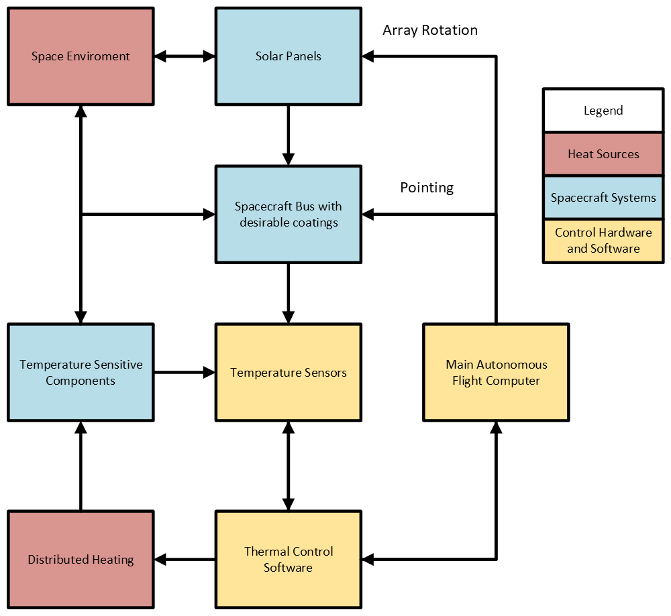

Figure 6: Block diagram of general thermal design

Temperature sensors throughout the spacecraft will interface with the thermal control software to recommend changes to the orientation of the spacecraft and operation of heating elements. The main flight computer will communicate these changes to the array rotation motors, pointing thrusters, or heaters depending on what is required to maintain spacecraft health.

## B. Thermal Scenarios

Based on a preliminarily sized spacecraft, discussed in the design section, the maximum and minimum temperatures at each location were calculated. The spacecraft was assumed to be spherical in terms of view factors, with each major surface having its own alpha and epsilon decided to ensure proper heat management.

Table 13: Spacecraft Temperatures through Mission Environments

|  |  |  |
| --- | --- | --- |
|  | **Max Temperature (Kelvin)** | **Min Temperature (Kelvin)** |
| Attached to launch vehicle | 290 | 286 |
| Earth Departure | 327 | 271 |
| Transfer to Mars | 316 (right after Earth) | 293 (right before Mars) |
| Orbit around Phobos | 271 | 244 |

For the transfer orbit, different temperature ranges were calculated to estimate the absolute maximum and minimum temperatures the spacecraft would experience while in transit. The highest temperature around Earth was calculated at the Karman Line, while the lowest temperature around Mars was calculated at the orbital height of Phobos without being in direct sunlight. These calculations included the heat transfer from the sun directly, infrared emissions, and albedo reflection. For the transit in space, this temperature was calculated by factoring in the orbit we will use to get to Mars. By calculating the position of the spacecraft at different times, taking into account the direct heat from the sun, infrared/albedo from Earth, and infrared/albedo from Mars, the lowest temperature could be found.

## C. Component Health

The minimum and maximum temperatures for each component were calculated to determine a desirable range the spacecraft could be held at. The operating temperatures of each component are available in the component list section. Compiling all the ranges gives an overall acceptable temperature range for the spacecraft of 273.15 K - 313.15 K. The only part which is an exception to the rule is the Gamma Ray Spectrometer which operates at a temperature of 80.15 K - 90.15 K. For this component, there will be a separate cooling system that is built into the component.

## D. Chosen Thermal Control Systems

The spacecraft is comprised of aluminum honeycomb, while the solar panels are made mainly of GaAs cells. Aluminum has a specific heat value of 897 . For passive thermal control, epoxy aluminum paint was chosen for the spacecraft. The solar cells are constructed with their own coating, which is displayed in Table 14.

Table 14: Coatings Chosen for Different Parts of the Spacecraft

|  |  |  |
| --- | --- | --- |
| **Component** |  |  |
| Spacecraft Paint | 0.77 | 0.31 |
| Solar Cell Coating | 0.88 | 0.80 |

For the overall active system, the heating thermal component chosen is the Omega KHLBA PLM-Series Electrical Heater and the cooling thermal component chosen is the SunPower-Ametek CryoTel DS Mini Cryocooler. The Omega KHLBA PLM-Series Electrical Heater was chosen due to its low power usage as well as its heating capabilities that satisfy the acceptable temperature range of the spacecraft. It also has been used on multiple SmallSats with a TRL value of 9. The SunPower-Ametek CryoTel DS Mini Cryocooler was chosen due to its long operating life span of over 23 years and cooling capabilities that satisfy the acceptable temperature range of the spacecraft. The capabilities of each overall active thermal system are shown in the Table 15 below.

Table 15: Capabilities of Active Thermal System

|  |  |  |
| --- | --- | --- |
| **Active Thermal Component** | **Temperature Regulation (K)** | **Power Draw (W)** |
| Omega KHLBA PLM-Series Electrical Heater | 233.15 - 422.15 | 15 |
| Ametek CryoTel DS Mini Cryocooler | 40.00 - temp of spacecraft | 80 |

To keep the Gamma Ray spectrometer at its operational temperature, an extra cooling system is required. The cooling system chosen is the Ricor K508 Stirling cycle cryocooler. This cooling system has been tested and proven to cool this specific instrument in similar thermal conditions, and itself has an operational temperature well within our range of acceptability. This cooler is capable of maintaining temperature stability to half a Kelvin. This system has an input power of approximately 12 watts.

Table 16: Gamma Ray Spectrometer System

|  |  |  |
| --- | --- | --- |
| **Component** | **Cooling Capability (K)** | **Power Draw (Watts)** |
| Ricor K508 Stirling Cycle Cryocooler | 65.00 - 110.00 | 12 |

The block diagram for the configuration of the active thermal components is shown in Figure 7 below.

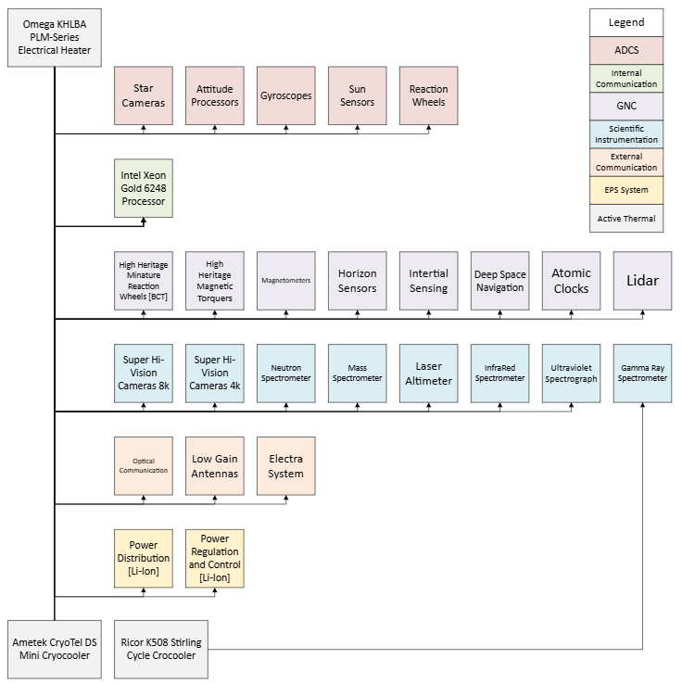

Figure 7: Block diagram of active thermal design

# Communication

## A. Main Communication System

For the main communication system, PHOCUS will be utilizing the Deep Space Network 70m antenna located in Barstow, California. This antenna is a part of the Goldstone Deep Space communications complex. This antenna will be used to obtain results and data from the spacecraft utilizing an optical system.

* Frequency Band: X-Band
* Band Width: 8200 – 8600 MHz
* Data Rate: 20 kW
* Modulation Type: DSN turnaround sequential-ranging modulation

For transmitting communications, the antenna has the following characteristics:

* Transmitter Loss: 0 (assuming 100% efficiency)
* Gain: 73.23 dBi
* Pointing Loss: 0.1 dBm
* Frequency Range: 7149.6-7188.9 MHz

For receiving communications, the antenna has the following characteristics:

* Receiver Loss: 0 (assuming 100% efficiency)
* Gain: 74.55 dBi
* Pointing Loss: 0.1 dB
* Frequency Range: -90 dBm

The maximum free space loss due to the maximum distance from Earth to Mars, at 401 million km (2.68 AU), is 278 dB.

This antenna has a recommended maximum signal power of -90 dBm. After performing calculations regarding the transmitter and receiver, the link power budget for this antenna is predicted to be -94.22 dBm.

## B. Tracking and Telemetry Controls System

For PHOCUS tracking and telemetry controls system, we make use of the Frontier X by Rocket Lab. This commercial component is a software defined, high data rate TT & C Radio used in the past for missions like ours. The radio was designed for near Earth and deep space missions, which makes it adaptable to our mission. In addition, the radio is designed for extensive functionality to enable radiometric navigation methods, precision timekeeping functions, FEC encoding and decoding, and a hardware based critical command decoder (CCD). Frontier-X is compatible with DSN waveforms and has a carrier sensitivity of –154 dBm.

For the low gain system, PHOCUS will be utilizing

* Frequency Band: X-Band
* Band Width: 300 kHz – 1.7 MHz
* Data Rate:
  + Downlink: 1.7bps -13.3Mbps (1.7MHz)
  + Uplink: 8.8bps - 1.8Mbps (1MHz)
* Modulation Type: PM, BPSK, QPSK, OQPSK
* While Frontier-X can handle each of these modulation types, the doubled data rate available with the Quadrature Phase Shift Keying makes it the most promising candidate for modulation.

## C. Electra Communications

For PHOCUS’s proximity operations, the Electra communications package will be utilized. Electra is a seasoned platform for communications between Martian spacecraft, allowing for space to space and space to Martian surface communications. The payload has the following characteristics.

* Frequency Band: 390 – 450 MHz
* Band Width: 10Hz – 10kHz
* Data Rate: 1kpbs – 4 Mbps
* Modulation Type: Suppressed and Residual Carrier Modes

Electra will use a steered antenna that has the following characteristics.

* Transmission and Receiving Loss: assuming ~2 dB
* Gain: 12 dBi
* Free Space Loss: 141.5 dBm at a worst-case distance of 10,000 km

Since the Electra package communicates between mostly identical versions of itself, the antenna used for transmission will have the same characteristics as the antenna used for receiving. Electra can receive a signal between -140 dBm and -70 dBm, so our reproduced implementation can work with the other on-orbit Electra systems. Values used for total calculations are shown below in Table 17.

Table 17: Electra Communications Signal Values

|  |  |  |  |
| --- | --- | --- | --- |
|  | **Main Communication System** | **Emergency Low Gain** | **Proximity Link** |
| **Ptx (+)** | 38 dBm | 14 dBm | 38.45 dBm |
| **Gtx (+)** | 71.23 dBmi | 36.73 dBi | 12 dBi |
| **Ltx (-)** | 0 dBi | 0 dBi | 0 dBi |
| **Lfs (-)** | 278 dB | 277.97 dB | 141.5 dB |
| **Lm (-)** | 0 dBi | 0 dBi | 2 dB |
| **Grx (+)** | 74.55 dBi | 73.23 dBi | 12 dBi |
| **Lrx (-)** | 0 dB | 0 dB | 0dB |
| **Total (-)** | 94.22 dBm | 154.04 dBm | 81.05 dBm |

# Electric Power System

## A. Power Production

The Roll Out Solar Array (ROSA) is an innovative solar array design which utilizes high strain one–piece carbon fiber composite slit-tube booms. The stored strain energy allows for the arrays to deploy and provides structural stiffness once fully deployed. This design allows for improved stowage efficiency and power density making it the best candidate for our power generation system.

Redwire Space claims a power production of 20kW for each IROSA which have panel dimensions of 21.336m by 5.486m (70ft x 18ft) (AR of ~0.25 width to height). This is a 0.171 power density. Another example is DART, which uses 6.6kW with 2 8m x 1.95m panels (AR of ~0.25 width to height). This is a 0.212 kW power density. DART gets slightly closer to the sun than the Earth, so let's assume the power benefits are mainly from this distance change. We can also assume the discrepancy is from using only publicly available numbers and estimates. Contacting Redwire Space would be needed to find a true number. Based on the average of these numbers and considering some solar panel efficiency gains since 2017, we can safely assume that a power density of 0.19 is reasonable to achieve.

Based on the Eq. (1) with an average orbital distance of 1.5237 AU for Mars, the panels will get 43.1% as much irradiance as at Earth, so the new power density will be 0.0818 . The panels can handle all voltages ranges from 12V to > 300V.

(1)

However, we should avoid high voltage activity as much as possible. Preliminary assuming our maximum solar array size is based off a 4m spacecraft height, we can use the aspect ratio of 0.25 to get a width of 4m and a length of 16 m. We can expect a maximum positive power budget of 10.47 kW using these dimensions and two panels. Based on our power needs we went with panels that produce 2.1 kW per panel with a 2.56 m x 10.8m power producing area. This includes a margin for when the panels inevitably degrade over the course of the mission.

## B. Power Storage

To store electricity while in orbital night, the spacecraft will employ three 55 amp hour batteries. At a nominal 12 V output, this will be able to provide 1980 Wh across the spacecraft. This includes a margin such that the batteries will have enough storage as they decay over the decade the spacecraft will be operational for.

## C. Power Regulation

Power will be balanced and regulated using built-in circuits that send necessary information to the main computer. Energy will be balanced and converted between the batteries and other systems. Any DC convertors will be picked such that they have the highest combination of efficiency and reliability.

## D. Power Usage

### 1. ADCS Power Usage

The total general power usage of the ACDS system components is 211 W. The breakup of each component’s power usage is shown in Table 18.

Table 18: ADCS Components Power Usage

|  |  |
| --- | --- |
| **ADCS Component** | **General Power Usage (W)** |
| Star Cameras | 88 |
| Gyroscopes | 1 |
| Sun Sensors | 18 |
| Reaction Wheels | 80 |
| Attitude Processors | 24 |

### 2. Internal Communication Power Usage

The total general power usage of the ACDS system components is 150 W. The breakup of each component’s power usage is shown in Table 19.

Table 19: Internal Communication Components Power Usage

|  |  |
| --- | --- |
| **Internal Communication Component** | **General Power Usage (W)** |
| Intel Xeon Gold 6248 Processor | 150 |

### 3. GNC Power Usage

The total general power usage of the GNC power distribution components is 68.45 W. The breakup of each component's power usage is shown in Table 20.

Table 20: GNC Components Power Usage

|  |  |
| --- | --- |
| **GNC Component** | **General Power Usage (W)** |
| High Heritage Miniature Reaction Wheels [BCT] | 10 |
| High Heritage Magnetic Torquers | 3 |
| Magnetometers | 1.5 |
| Horizon Sensors | 1 |
| Inertial Sensing | 40 |
| Deep Space Navigation | 12.5 |
| Atomic Clocks | 0.45 |
| Lidar | 30 |

### 4. Scientific Instrumentation Power Usage

The total general power usage of the scientific instrumentation power distribution components is 317 W. The breakup of each component's power usage is shown in Table 21.

Table 21: Scientific Instrumentation Components Power Usage

|  |  |
| --- | --- |
| **Scientific Instrumentation Component** | **General Power Usage (W)** |
| Super Hi-Vision Camera (8k) | 30 |
| Super Hi-Vision Cameral (4k) | 30 |
| Gamma Ray Spectrometer | 32 |
| Neutron Spectrometer | 32 |
| Mass Spectrometer | 170 |
| Laser Altimeter | 22 |
| InfraRed Spectrometer | 0.5 |
| Ultraviolet Spectrograph | 0.5 |

### 5. Thermal Power Usage

The total general power usage of the thermal power distribution components is 347 W. The breakup of each component's power usage is shown in Table 22.

Table 22: Thermal Components Power Usage

|  |  |
| --- | --- |
| **Thermal Component** | **General Power Usage (W)** |
| General Heaters | 225 |
| Cryocooler | 72 |
| Thermal Infrared Sensor | 50 |

### 6. External Communications Power Usage

The total general power usage of the thermal power distribution components is 194 W. The breakup of each component's power usage is shown in Table 23.

Table 23: External Communication Components Power Usage

|  |  |
| --- | --- |
| **External Communications Component** | **General Power Usage (W)** |
| Optical Communication | 100 |
| Low Gain Antennas | 24 |
| Electra System | 70 |

### 7. EPS System Power Usage

The total general power usage of the EPS system power distribution components is 25 W. The breakup of each component's power usage is shown in Table 24.

Table 24: EPS System Components Power Usage

|  |  |
| --- | --- |
| **EPS System Component** | **General Power Usage (W)** |
| Power Distribution | 20 |
| Power Regulation and Control | 5 |

### 8. Total Power Usage

The total power usage of the spacecraft is estimated to be 1342.45 W. The breakup of the power usage of each spacecraft system is shown in Table 25.

Table 25: Total Power Usage

|  |  |
| --- | --- |
| **Spacecraft System** | **General Power Usage (W)** |
| ADCS | 211 |
| Internal Communication | 150 |
| GNC | 68.45 |
| Scientific Instrumentation | 317 |
| Thermal | 347 |
| External Communication | 194 |
| EPS System | 25 |

# Data Handling

## A. Overall Component Data Transfer

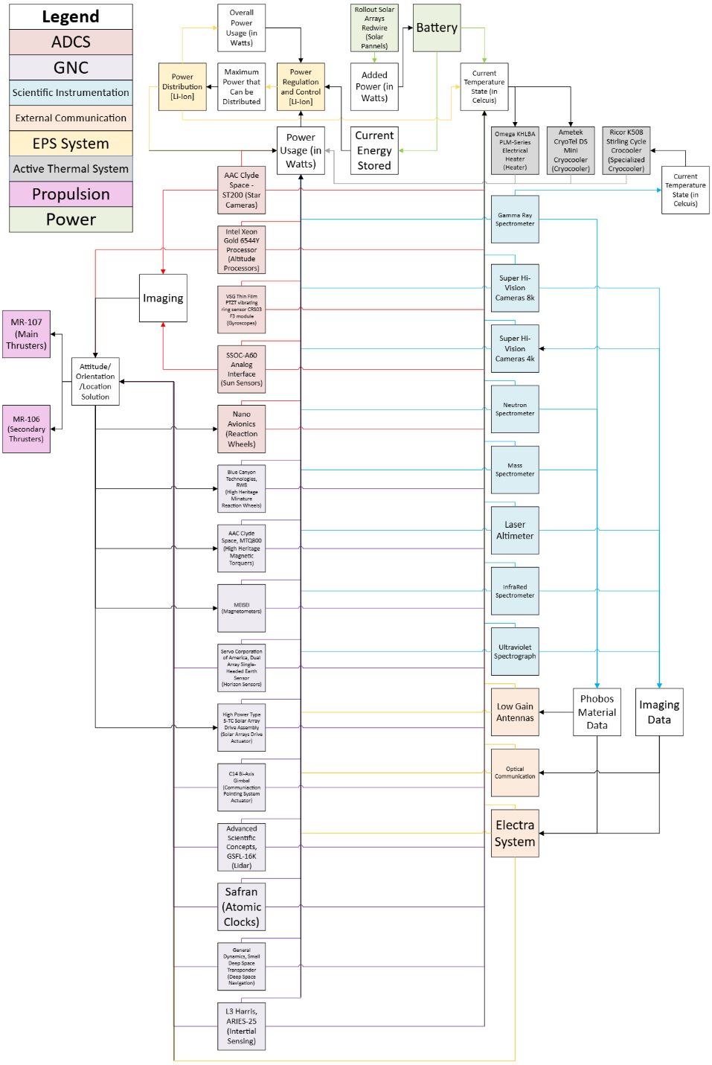

Figure 8: Displays the data each component needs and gives out to other components of the spacecraft

## B. Flight Software

The flight software will be built upon previous Mars heritage flight software, utilizing RS-422 and RS-485 standards.

## C. Interface Control Document

This section summarizes the requirements of each component, as well as how each component is connected to another system. It sets the precedence of how the spacecraft components interact and operate; therefore, it is the highest authority documentation in the event of a conflict. This Interface Control Document defines the interface requirements between the following components to ensure the accurate flow of information throughout the system:

1. Star Cameras to Computer
2. Computer to Gyroscopes
3. Laser Altimeter to Computer
4. Computer to Reaction Control Thrusters
5. Neutron Spectrometer to Computer
6. Low Gain Antenna to Computer
7. Solar Panels to Electrical Power Regulation System
8. Horizon Sensors to Computer
9. Computer to Thermal Heater
10. InfraRed Spectrometer to Computer

## D. Star Cameras to Computer

### 1. Interface Description

A star camera is a device that recognizes star patterns, such as constellations. The star camera will observe the area surrounding the spacecraft, taking pictures of the star patterns in its view. The star camera will locate the positions of stars and report them to the spacecraft. These images will include different brightness of stars. The captured images will then be compared to a celestial map that resides in the spacecraft computer memory.

### 2. Interface Responsibilities

The star cameras will send the images taken directly to the computer system. The computer will analyze the images to determine the location of the spacecraft. This information will be sent to the gyroscopes to make necessary orientation adjustments when needed.

### 3. Coordinate Systems

The coordinate systems used will be the International Celestial Reference System (ICR), IAU_PHOBOS, and the IAU_MARS frame provided by the NAIF Spice toolkit.

### 4. Engineering Units

The distance calculated from analyzing the images will be reported in kilometers.

### 5. Mass Properties

The star cameras have an estimated mass of 0.085 kg. With eight-star cameras, the total mass for this subsystem is estimated to be 0.68 kg.

### 6. Environment

The star cameras are capable of operating within a temperature range of 253.15 K – 313.15 K. In the case of an overheating event, the chip will shut down automatically and restart when the device reaches an acceptable lower temperature.

### 7. Electrical (Power)

The star tracker requires a minimum of 3.6 V to maintain operations and can use up to 34.0 V. This corresponds to a minimum required power of 0.37 W to a maximum of 1 W. The logical voltage within the device will use a maximum common mode voltage of –7 V – 12 V when using the RS-485 standard.

### 8. Electronic (Signal)

The star tracker will communicate with the main computer using a bidirectional RS422/ RS-485 standard.

### 9. Software and Data

The star tracker will send a quaternion representing the orientation of the spacecraft with respect to the ICRS frame which will then be converted by the main computer into the IAU_MARS and IAU_PHOBOS frame. The quaternion will consist of 4 signed 32-bit integers updated at a 5 Hz frequency.

### 10. Error Handling

The camera has two main error modes, unable to image and unable to power on. The first mode will be output under two main conditions, either outside of operating temperatures and/or under a slew rate outside of specifications. The camera will automatically shut off in either of these cases and output an error code in the form of an address to the computer. The error codes will be added once the datasheet is received from the manufacturer.

## E. Computer to Gyroscopes

### 1. Interface Description

Gyroscopes are used to measure and maintain the orientation and angular velocity of the spacecraft. With proper data sent that shows the rate of change of the rotation of the spacecraft, the gyroscopes would be able to reorient the spacecraft.

### 2. Interface Responsibilities

When the computer determines the current location of the spacecraft, these images will be compared to previously stored images. This will allow the rate of change that the spacecraft has rotated to be sent to the gyroscopes. This information will be sent to the gyroscopes to make necessary orientation adjustments when needed.

### 3. Coordinate Systems

The coordinate system used will be the International Celestial Reference System (ICRS), IAU_PHOBOS and the IAU_MARS frame provided by the NAIF Spice toolkit.

### 4. Engineering Units

The velocity will be measured in meters per second and the angular velocity will be measured in radians per second.

### 5. Mass Properties

The gyroscopes are estimated to have a mass of 0.00005 kg.

### 6. Environment

The gyroscopes are capable of operation within a temperature range of 233.15 K – 358.15 K. In the case of an overheating event, the gyroscope would become inoperable until the cooling system could bring them back within their acceptable temperature range.

### 7. Electrical (Power)

Gyroscopes require a supply voltage of 5 V or less when using the CRS43.

### 8. Electronic (Signal)

The gyroscope will output a DC voltage proportional to rate of turn and input voltage. Ground testing will characterize which voltage value corresponds to each angular rate. During flight, the DAQ will convert this output voltage into a digital signal using this characterization and send it to the main computer.

### 9. Software and Data

The gyroscope consists of a spinning rotor that maintains its axis in space, therefore any rotation that is experienced is proportional to the change in orientation. This allows for the angular velocity data to be obtained and utilized by other components within the ADCS system. The bias instability is given at 12 degrees/hour creating small margins of error while the measurable range of the gyroscope is up to 200 degrees/s.

### 10. Error Handling

The gyroscopes have an internal software program that can calculate bias ratiometric error and scale factor ratiometric error internally. This will ensure that if there are any slight unforeseen orientation deviations or that the sensor has an internal error skewing the data, the gyroscopes can correct the error and orient the spacecraft correctly. In addition to this, the spacecraft has four gyroscopes. If two of the gyroscopes cease to function, the spacecraft can still orient properly.

## F. Laser Altimeter to Computer

### 1. Interface Description

 A laser altimeter is a device that uses light pulses to determine the range between two objects. This range is determined by measuring the time it takes for radar pulses to hit an object and bounce back towards the spacecraft.

### 2. Interface Responsibilities

With proper data sent that shows the range between an object in space and the spacecraft, the spacecraft will be able to know where it is in space and can use that data to reorient if need be. These data results would later be sent to navigation and attitude control systems. In addition, the shape of the surface and current altitude can be determined.

### 3. Coordinate Systems

The coordinate systems used will be the International Celestial Reference System (ICRS), IAU_PHOBOS, and the IAU_MARS frame provided by the NAIF Spice toolkit.

### 4. Engineering Units

The distance measured by the Laser Altimeter will be in kilometers.

### 5. Mass Properties

The laser altimeter is estimated to have a mass of 7.4 kg.

### 6. Environment

The Laser Altimeter is operational between 233.15 K – 333.15 K. In the case of overheating, the monitoring sensor typically reports an error.

### 7. Electrical (Power)

Laser Altimeters require 30 Watts when using the GSFL-16K Flash LIDAR.

### 8. Electronic (Signal)

The laser altimeter can use both Ethernet and RS422-High Speed Serial input and output.

### 9. Software and Data

The laser altimeter will measure the distance from the spacecraft to the surface of Phobos and transmit altitude data to the main computer. The system will determine altitude based on time-of-flight measurements of laser pulses, which will be processed and referenced to the IAU_PHOBOS and IAU_MARS frame.

The altitude data will be transmitted as a range map and intensity map using a floating-point value. Each measurement will be accompanied by the timestamp, measurement confidence level, and surface reflectivity estimate. Data will be updated at a frequency, depending on the spacecraft’s operational mode (orbit, descent, or landing). This information will support terrain-relative navigation, hazard avoidance, and mapping of Phobos' surface.

### 10. Error Handling

The laser altimeter uses edge detection which means that the stop-pulse timing is done with a constant fraction discriminator. This makes pulse timing independent of pulse amplitude. While this means that the effects of nonuniform surface roughness and slope over the footprint of the beam would be included in the measurements. While this can affect the measurements, it will not be an issue as the transmitter beam will decrease in size as it approaches the target. In addition to this, the transmitter laser will overlap data with the receiver field of view to ensure the energy reflected is captured.

## G. Computer to Reaction Control Thrusters

### 1. Interface Description

The reaction control thrusters are placed strategically around the spacecraft. These thrusters are used to perform maneuvers once in space, including rotational and attitude adjustments in space. This system is responsible for providing proper orientation in space.

### 2. Interface Responsibilities

Information for these maneuvers to occur will be gathered from the computer. This information will include the current orientation of the spacecraft, the distance between objects in space, and the distance between the spacecraft and Phobos.

### 3. Coordinate Systems

The coordinate systems used will be the International Celestial Reference System (ICRS), IAU_PHOBOS, and the IAU_MARS frame provided by the NAIF Spice toolkit.

### 4. Engineering Units

The rotational motion of the reaction control thrusters is measured in radians.

### 5. Mass Properties

The reaction control thruster is 1.46 kg. With 16 reaction control thrusters, the total mass for this component is 23.36 kg.

### 6. Environment

The operational temperature of the reaction control thrusters is between 233.15 K – 873.15 K.

### 7. Electrical (Power)

Each reaction control thruster will require 5 watts to maintain steady state power when using the VACCO X13003000-01.

### 8. Electronic (Signal)

The reaction control thrusters and its component sensors will communicate with the main computer using a bidirectional RS422/ RS-485 standard.

### 9. Software and Data

The reaction control thrusters will receive commanded thrust levels and firing durations from the main computer for attitude adjustments and small translational maneuvers. The commands will be transmitted as an 8-bit unsigned integer per thruster, representing discrete thrust levels. Each command packet will include a timestamp, and a thruster status flag indicating active or idle state.

Thruster telemetry data, including firing duration, and chamber pressure, will be transmitted back to the main computer at a 10Hz frequency for system monitoring and corrections.

### 10. Error Handling

There are sixteen reaction control thrusters as redundancy. The spacecraft will be able to maneuver if some of the thrusters cease to function or run out of propellant.

## H. Neutron Spectrometer to Computer

### 1. Interface Description

The Neutron Spectrometer is used to determine thermal and epithermal neutron flux. This will then be used to determine the local hydrogen content in the surrounding space. This method consists of measuring atomic and magnetic motions through the measurement of kinetic energy of neutrons.

### 2. Interface Responsibilities

Through the measurements that the neutron spectrometer makes, the planetary composition and the radiation present in the current atmosphere can be determined. Radiation can heat up the spacecraft as more of it is absorbed. Proper data from the Neutron Spectrometer measurements will be sent to the computer for storage and to be able to figure out if the spacecraft needs heating or cooling. In addition, data resulting from cosmic rays bouncing off Phobos’s surface will be recorded for compositional measurements.

### 3. Coordinate Systems

The coordinate systems used will be the International Celestial Reference System (ICRS), IAU_PHOBOS, and the IAU_MARS frame provided by the NAIF Spice toolkit.

### 4. Engineering Units

The unit used for the Neutron Spectrometer is the electron volts.

### 5. Mass Properties

The Neutron Spectrometer system has an estimated mass of 1.6 kg

.

### 6. Environment

The operational temperature of the Neutron Spectrometer system is withing the range of 243.15 K – 313.15 K. However, it would still survive for 233.15 K – 333.15 K.

### 7. Electrical (Power)

The electrical operation of the Neutron Spectrometer requires 50 Hz at 230 V using the SP2.

### 8. Electronic (Signal)

The Neutron Spectrometer will communicate with the main computer using the RS422 standard.

### 9. Software and Data

The Neutron Spectrometer will detect neutrons emitted from Phobos' surface to analyze the presence of hydrogen-rich materials, such as water ice or hydrated minerals. The spectrometer will measure neutron flux across different energy levels, aiding in subsurface composition studies. The instrument will generate spectral count data, transmitted as two 32 channel spectra. Each channel is one byte deep and there is one set of channels for the bare sensor and then one for the cadmium wrapped sensor.

Each data packet will include a timestamp and a detector status flag, indicating operational status, background radiation level, and spacecraft altitude. The instrument will operate in both passive and active modes, with integration periods adjusted based on altitude and mission phase for scientific analysis and resource mapping.

### 10. Error Handling

If this system fails, no data will be collected. The mission would still be operable as other forms of data can still be collected.

## I. Low Gain Antenna to Computer

### 1. Interface Description

A low gain antenna will provide a wide range of coverage. This antenna will serve as the main communication source between the spacecraft and the station on Earth and allow control of various functions.

### 2. Interface Responsibilities

Any data, updates, or other information needed to get to the computer can get to the spacecraft through this method.

### 3. Coordinate Systems

The coordinate systems used will be the International Celestial Reference System (ICRS), IAU_PHOBOS, and the IAU_MARS frame provided by the NAIF Spice toolkit.

### 4. Engineering Units

The measured unit of the Low Gain Antenna is dBi.

### 5. Mass Properties

The mass of the low gain antenna is estimated to be 2 kg.

### 6. Environment

The operational temperature of the Low gain antenna is 248.15 K – 328.15 K. However, between the ranges of 238.15 K – 343.15 K, there is no damage done to its components.

### 7. Electrical (Power)

The low gain antenna will require approximately 30 V using the Frontier-X by Rocket Lab.

### 8. Electronic (Signal)

The low gain antenna will use the SpaceWire standard which includes command, telemetry, data, and time options.

### 9. Software and Data

Frontier-X is compatible with the Deep Space Network for communication over X-band at approximately 8.4 GHz and includes a coherent transponder, enabling radiometric navigation methods, FEC encoding and decoding, hardware based critical command decoder. These are used to transmit data from our spacecraft components to the ground station for monitoring. It has a gain of 36.73 dB with a 1m antenna, 300 kHz –1.7 MHz bandwidth capability, and a Quadrature Phase Shift Keying modulation type for uplink speeds at approximately 1 Mbps and downlink speeds pf approximately 1.7 Mbps.

### 10. Error Handling

The Electra system has the capacity to handle external communications if the low gain antenna is not operational. In addition to this, the spacecraft can store data until it is recovered if all external communications are not functioning.

## J. Solar Panels to Electrical Power Configuration System

### 1. Interface Description

The solar panels will provide the spacecraft with all its electrical power for almost every phase of flight. The only time this interface is not in use is during battery power operations during launch and right after deployment.

### 2. Interface Responsibilities

This interface is responsible for storing the energy gained through the solar panels and sending it to the electrical power configuration system to provide power for the spacecraft.

### 3. Coordinate Systems

The coordinate systems used will be the International Celestial Reference System (ICRS), IAU_PHOBOS, and the IAU_MARS frame provided by the NAIF Spice toolkit.

### 4. Engineering Units

The Solar Panels to Electrical Power Configuration System involves multiple units depending on the parameter being measured. Some of the major parameters being measured include Solar Panel Output, which will be measured in Watts, Volts, and Amperes, and power distribution in Volts.

### 5. Mass Properties

The estimated mass of these components is 110.4 kg.

### 6. Environment

The operational temperature of the reaction control thrusters is between 233.15 K – 358.15 K.

### 7. Electrical (Power)

The Single Wing Size option for the Redwire Roll Out Solar Array creates between 1 kW – 30 kW. Our specific sizing will provide 2.1 kW per wing.

### 8. Electronic (Signal)

The solar panel will provide a set of DC voltages that represent the produced current, voltages, and power provided by the solar panels. Ground testing will produce a characterization equation that will be used by the onboard DAQ to provide the telemetry data. If the EPS detects any potential issues it can communicate to the main computer using the RS422 standard.

### 9. Software and Data

No motors or complex mechanisms are required for the operation, the data to be obtained is the received power capable of 100 W/kg – 120 W/kg and a voltage range of 12 V – 300 V.

### 10. Error Handling

There are two solar panels so that in the event one is non-operational, the other can still draw power. If both are non-operational, then the system is designed to conserve energy and operate for as long as possible with the remaining battery that it has.

## K. Horizon Sensors to Computer

### 1. Interface Description

Horizon Sensors are used to determine the satellite's orientation relative to Earth or another planet by measuring infrared radiation. By detecting this radiation around a planet, the relative position regarding the planet's atmosphere can be determined. In addition, these sensors can also detect temperature differences between the poles and the equator.

### 2. Interface Responsibilities

The information gathered from the horizon sensors will be sent to the computer, which will be stored and used for navigation and attitude control based on where the spacecraft is in space.

### 3. Coordinate Systems

The coordinate systems used will be the International Celestial Reference System (ICRS), IAU_PHOBOS, and the IAU_MARS frame provided by the NAIF Spice toolkit.

### 4. Engineering Units

The horizon sensor measures temperature in Kelvin and the distance above the horizon in radians.

### 5. Mass Properties

The mass of the horizon sensors is estimated to be 0.00035 kg.

### 6. Environment

The operational temperature of the horizon sensors is from 243.15 K – 328.15 K. However, when overheating, it can lead to system errors, inaccurate readings, and eventual system shut down.

### 7. Electrical (Power)

The Dual Array Single Head Earth Sensor requires 1 Watt of power.

### 8. Electronic (Signal)

The horizon sensor produces DC voltages from redundant IR detector arrays viewing the Earth, horizon, and Space with a data acquisition rate of 20 Hz. Ground testing will characterize the produced voltages and the onboard DAQ will use the found characterization equation to send the orientation data to the main computer.

### 9. Software and Data

The horizon sensors utilize a mirror, lens, and infrared sensor to determine the horizon of a celestial object relative to the spacecraft for information on how to orient the spacecraft.

### 10. Error Handling

The horizon sensor has redundant IR detector arrays. It also uses Earth and space pixels to normalize the horizon data which reduces errors caused by orbital radiance variations and seasonal variations.

## L. Computer to Thermal Heater

### 1. Interface Description

The thermal heater on the spacecraft will be used to maintain the temperatures on the spacecraft, keeping all components in their desirable ranges. This will be important in keeping all components operational and preventing overheating or freezing. The computer must be able to send signals to the heater telling it when to turn on and off based on drawn power.

### 2. Interface Responsibilities

This interface is responsible for maintaining proper operating temperatures and communicating overall thermal health data to the main computer.

### 3. Coordinate Systems

The coordinate systems used will be the International Celestial Reference System (ICRS), IAU_PHOBOS, and the IAU_MARS frame provided by the NAIF Spice toolkit.

### 4. Engineering Units

All temperatures will be denoted in Kelvin.

### 5. Mass Properties

The full suite of thermal heaters should weigh approximately 6 kg.

### 6. Environment

The operating temperature of the thermal heaters is 125 K – 573 K. The heater will automatically shut off using built in thermal switches.

### 7. Electrical (Power)

The power draw will vary depending on the exact temperature that needs to be maintained. The range is 0.02 W/cm2 – 7.75 W/cm2. The logical voltage within the device will use a maximum common mode voltage of -7 V for 12 V when using the RS-485 standard.

### 8. Electronic (Signal)

The integrated temperature sensors use the RS-485 standard.

### 9. Software and Data

The heaters will output a temperature measurement within a range of 173 K – 723 K. The heating thermal heaters have integrated thermal switches, sensors, and cut-offs. The heater elements have a dielectric strength of 197 KV/MM and have shaded watt densities available for even heat distribution.

### 10. Error Handling

The heater has one main error mode: unable to power on. The first mode will be output under two main conditions, either an electrical interruption or sensor overheating. The heater will output an error code in the form of an address to the computer. The error codes will be added once the datasheet is received from the manufacturer.

## M. InfraRed Spectrometer to Computer

### 1. Interface Description

An InfraRed Spectrometer measures the vibrations of atoms, and it analyzes how molecules are able to absorb infrared light. This data can provide information regarding the structure, composition, and identity of specific substances in space. This information will be used to determine which gases are in the atmosphere and how much of each gas is present.

### 2. Interface Responsibilities

The InfraRed Spectrometer will measure the distribution of hydrous minerals in the atmosphere. Also, it will measure the water related substances found and any organic matter that is found in Phobos's atmosphere.

### 3. Coordinate Systems

The coordinate systems used will be the International Celestial Reference System (ICRS), IAU_PHOBOS, and the IAU_MARS frame provided by the NAIF Spice toolkit.

### 4. Engineering Units

An infrared spectrometer measures the wavenumber in reciprocal centimeters and the wavelength in micrometers. Absorbance will be measured as a percentage.

### 5. Mass Properties

The estimated mass of the Infrared Spectrometer is 38 kg.

### 6. Environment

The operational temperature of the Infrared Spectrometer is 243.15 K – 313.15 K, and at temperature ranges 233.15 K – 333.15 K it is survivable.

### 7. Electrical (Power)

The power required for the Infrared Spectrometer is 100 mA at 5 VDC for the HR-X Extreme Hi-Resolution Spectrometer.

### 8. Electronic (Signal)

The IR radiation will be passed through the sample, which will allow some of the radiation to be absorbed and transmitted. The resulting spectrum will include the molecular absorption and transmission, which will create a molecular fingerprint of the sample. The spectrum will be communicated to the main computer using the RS422 standard which is provided via a control interface upgrade.

### 9. Software and Data

The infrared spectrometer will analyze the spectral composition of Phobos’ surface materials by measuring reflected and emitted infrared radiation. This data will help identify minerals, surface temperature variations, and potential volatiles such as water-bearing compounds. Infrared radiation is passed through a sample of the organic compound and then into a detector which measures the intensity of the transmitted radiation at different wavelengths.

The spectrometer will generate spectral intensity data across a defined wavelength range, transmitted as an array representing intensity values for each spectral band. Each data packet will include the timestamp, spectral resolution, surface temperature estimate, incidence and emission angles, and instrument status flag indicating operational mode.

### 10. Error Handling

If this system fails, no data will be collected. The mission would still be operable as other forms of data can still be collected.

# Launch Vehicle

## A. Launch Vehicle Choice

To achieve its goals, the PHOCUS mission needs a launch vehicle capable of delivering the spacecraft to its target orbit around Phobos from the surface of Earth. The exact extent of how far the launch vehicle will get us could vary based on a lot of mission parameters, but the PHOCUS team has narrowed down this choice. The launch vehicle will bring the spacecraft to a Hohmann transfer orbit then separate. The spacecraft itself will complete the rest of the maneuvers using onboard propulsion. Using the patched conics method as well as an estimate of 9200 m/s needed to reach a 200 km parking orbit, the launch vehicle would need to provide 12,145 m/s of delta-V to our spacecraft.

## B. Falcon 9 Properties

The Falcon 9 is a launch vehicle produced by SpaceX. It’s important and relevant properties are summarized below in Table 26 as well as where the information was obtained from, be it from SpaceX or another source. Falcon 9 has had many successful launches with payloads from many companies in the past and currently, however, has a smaller payload mass.

Table 26: Falcon 9 Capabilities Characteristics Table

|  |  |
| --- | --- |
| **Characteristic** | **Data** |
| Height | 47.7 m |
| Main Width | 5.2 m |
| Stages | 2 |
| Stage One Mass | 25600 kg structural & 421300 kg fueled |
| Stage Two Mass | 3900 kg structural & 96570 kg fueled |
| Payload Mass | ~4000 kg to a Hohmann Transfer to Mars |
| Useable Payload Volume | 278.21 m^3 |
| Stage One Delta-V | 4576 m/s |
| Stage Two Delta-V | 8685 m/s |
| Total Delta-V | 13261 m/s |
| Cost per launch | $62 million USD |
| Expected Availability | Availability by the Jan 8th window is expected using 2024 statistics of 133 successful flights in 2024 |
| Vehicle Manufacturer and Launch Service Provider | SpaceX |
| Propellant Requirements | Two-Stage liquid oxygen (LOX) and rocket grade kerosene (RP-1) |

# Spacecraft Architecture

There are several main considerations the PHOCUS mission needs to succeed, in terms of mechanical design. The spacecraft must contain and protect each subsystem from the space environment and fit within the payload fairing. It must also be able to support deployment structures, mainly the solar array actuators and the ROSAs.

The spacecraft is designed to be as physically small as possible while still fitting each subsystem and has mounts for the solar arrays to be able to rotate on orbit. Below is the launch configuration. The side connected to the launch mount contains the main engines. The burns the spacecraft needs to make with those engines do not require large nozzles which would interfere. This removes the need to mount the spacecraft on a different face.

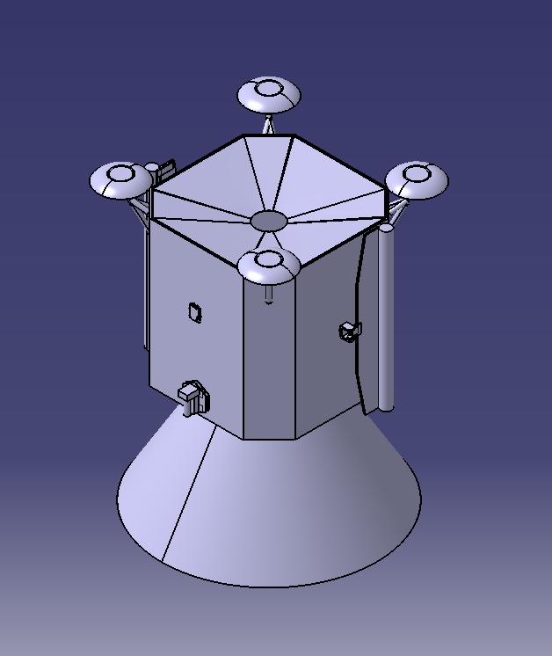

Figure 9: PHOCUS on the payload mount

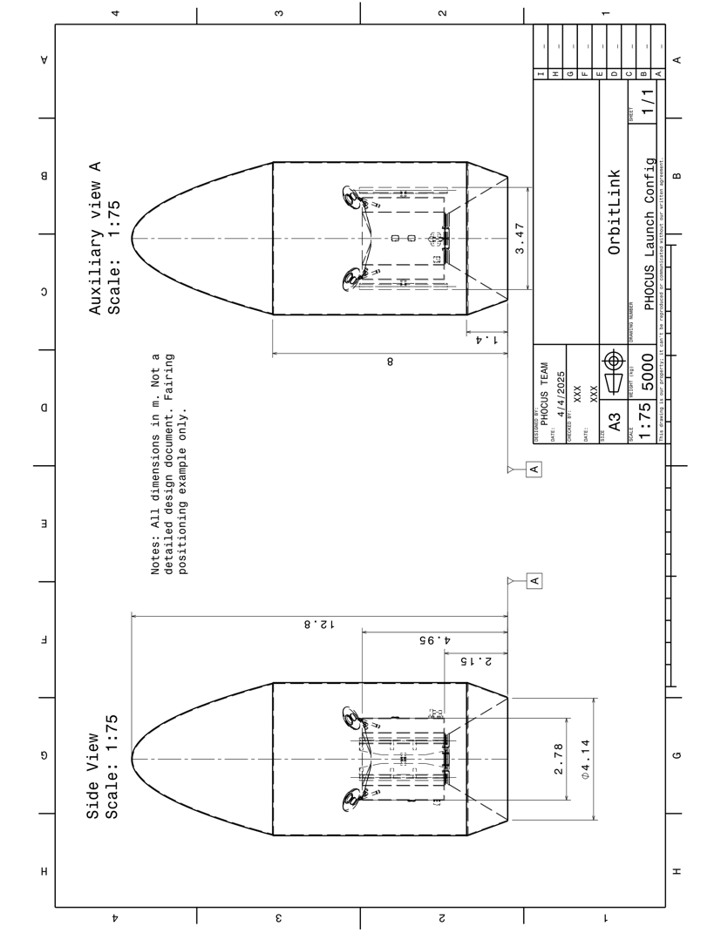

Figure 10: Drawing of the launch configuration

The ROSAs are the primary concern for deployment after spacecraft separation, but being high heritage parts, there is plenty of knowledge to avoid any issues. While not pictured here, there will also be reaction control thrusters mounted in pairs to provide control authority and perform trajectory correction maneuvers and to desaturate the reaction wheels.

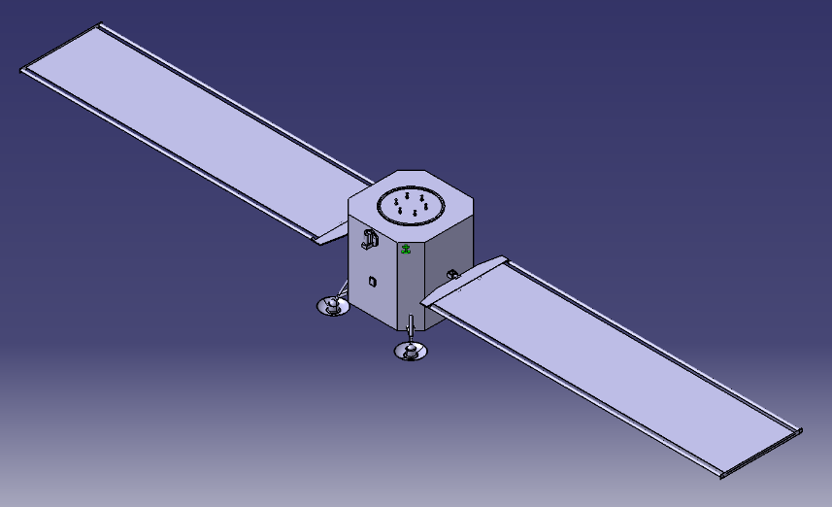

Figure 11: In space deployed configuration

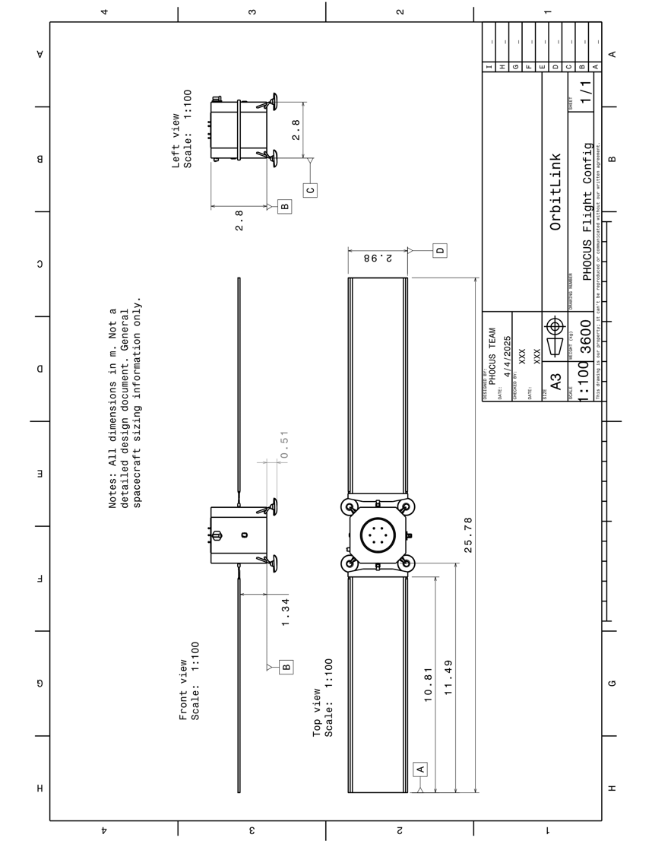

Figure 12: Drawing of the deployed configuration

The end of mission landing requires landing gear and a sample collection system to provide the sample analysis suite with access to the Phobos regolith. Ideally these systems would both be passive and need to fit within the 4.57 m diameter internal envelope of the fairing.

To accommodate passive landing gear, the corners of the vehicle are chamfered to provide a flat surface to mount the landing gear and to reduce the size from end to end. To decrease the size further, the landing pad surface area can be minimized. Phobos has a very low gravity, and the spacecraft only weighs ~20.5 N there. Even with a pad surface area of 2.29 m2, the pressure exerted on the ground is only ~10 Pa, which will not significantly disturb the ground. With this design, the spacecraft fits comfortably within the envelope.

# Spacecraft Component List

## A. Attitude Determination & Control System (ADCS)

### 1. ST400 STAR TRACKER

Component Description:

Star cameras have low mass, lower power consumption, and low drift was to determine spacecraft orientation. The ST400 is high TRL, in use on multiple missions, and has high measurement accuracy. The star cameras capture images using a small FOV and long focal length camera, processes the image data to confirm the star positions, execute algorithms that identify and compare the observed stars with a star database, and determine the spacecraft’s orientation based on the relative position of the observed stars. The spacecraft will have eight start trackers. They will be connected to the main bus, main computer, and other star trackers.

Table 27: ST400 Star Tracker General Properties Table

|  |  |
| --- | --- |
| **Property** | **Unit** |
| Mass | 280 g |
| Length x Width x Height | 53.8 mm x 53.8 mm x 90.5 mm |
| Operational Temp Range | 253 K – 313 K |
| Power Usage | 0.37 - 0.7 - 1.00 W |
| Supply Voltage | 3.6 V – 34.0 V |
| Update Rate | 5 Hz |
| Radiation Tolerance | 9 krad |

Software and Data Requirements:

The star tracker will send a quaternion representing the orientation of the spacecraft with respect to the ICRS frame which will then be converted by the main computer into the IAU_MARS and IAU_PHOBOS frame. The quaternion will consist of four signed 32-bit integers updated at a 5 Hz frequency.

Additional Information:

Due to periodic variations in solar radiation, there is temperature fluctuation which also affects the measurement accuracy of the optical system.

### 2. CRS43 Gyroscopes

Component Description:

Gyroscopes are used for attitude control, navigation, and spacecraft maneuvers. They are designed to withstand high temperatures, vibrations, and accelerations, which makes them suitable for the PHOCUS mission. The CRS43 gyroscope delivers high performance motion sensing, even under sever shock and vibration. When the computer determines the rate of change of the angular velocity of the spacecraft, the information will be sent to the spinning rotor of the gyroscope. The spacecraft will have four gyroscopes. They will be connected to the main bus and main computer.

Table 28: CRS43 Gyroscope General Properties Table

|  |  |
| --- | --- |
| **Property** | **Unit** |
| Mass | 0.05 g |
| Length x Width x Height | 29 mm x 29 mm x 18.4 mm |
| Operational Temp Range | 233.15 K – 358.15 K |
| Power Usage | 1 W |
| Supply Voltage | 5V |
| Bandwidth | 24 Hz |
| Angular Rate Range | ±100 degree/second |
| Cost | $135.19 |

Software and Data Requirements:

The gyroscope consists of a spinning rotor that maintains its axis in space, therefore any rotation that is experienced is proportional to the change in orientation. This allows for the angular velocity data to be obtained and utilized by other components within the ADCS system. The bias instability is given at 12 degrees/hour creating small margins of error while the measurable range of the gyroscope is up to 200 degrees/s.

Additional Information:

The gyroscopes have an internal software program that can calculate bias ratiometric error and scale factor ratiometric error internally. This will ensure that if there are any slight unforeseen orientation deviations or that the sensor has an internal error skewing the data, the gyroscopes can correct the error and orient the spacecraft correctly.

### 3. SSOC-A60 Sun Sensor on a Chip

Component Description:

The purpose of sun sensors is to determine the orientation of the sun with respect to a reference coordinate system in the spacecraft. This is done by detecting the intensity difference between radiation observed at a solid angle from the Sun’s boundaries and radiation observed from adjacent regions in the sensor’s field of view. This helps with determining where the sun is with respect to the spacecraft and will be used to determine the orientation and position of the spacecraft as it traverses from Earth to Phobos. The spacecraft will have six sun trackers. They will be connected to the main bus, main computer, and other sun trackers.

Table 29: SSOC-A60 Sun Sensor General Properties Table

|  |  |
| --- | --- |
| **Property** | **Unit** |
| Mass | 25 g |
| Length x Width x Height | 30 mm x 30 mm x 12 mm |
| Operational Temp Range | 228.15 K – 358.15 K |
| Survivable Temp Range | 223.15 K – 363.15 K |
| Power Usage | < 12 mW |
| Voltage Relation | 5 V |
| Field of View | ±60° |
| Accuracy | < 0.3° |
| Precision | < 0.05° |
| Lifetime | > 5 years |

### 4. Nano Avionics Reaction Wheels

Component Description:

The purpose of reaction wheels is to create torque in the spacecraft to ensure that its orientation is within the appropriate parameters. Data from instruments, such as the sun sensors, will send information on the orientation and location of the spacecraft to the attitude processors. The attitude processors will determine if the spacecraft is within tolerance of the orientation, it should be in and send signals to the reaction wheels to align the spacecraft’s orientation back to the acceptable parameters while traversing to Phobos. The spacecraft will have four reaction wheels. They will be connected to the main bus, main computer, and other reaction wheels.

Table 30: Nano Avionics General Properties Table

|  |  |
| --- | --- |
| **Property** | **Unit** |
| Mass (Entire System) | 700 g |
| Operational Temp Range | 233.15 K – 358.15 K |
| Survivable Temp Range | 233.15 K – 358.15 K |
| Power Usage | 0.180 W |
| Voltage Relation | 5 V |
| Maximum Torque (X-Axis) | 5.9 mNm |
| Maximum Torque (Y-Axis) | 5.9 mNm |
| Maximum Torque (Z-Axis) | 2.5 mNm |

Software and Data Requirements:

The Reaction Wheels support Binary Protocol and Command Line Interface. Command ID and Result Codes takes 1 byte of data.

Additional Information:

When handling the Reaction Wheels, gloves should be worn. In addition, any accumulated charge on a person’s body needs to be removed before touching the reaction wheels. Sources of static electricity need to be kept one meter away from the equipment.

### 5. Intel® Xeon® Gold 6544Y Attitude Processor

Component Description:

The attitude processor is the attitude determination and control software; this component is designed to control the attitude of the spacecraft. The chosen attitude processor provides high-performance computing for space Attitude Determination and Control Systems (ADCS). Its multi-core architecture handles complex algorithms for real-time sensor data processing, attitude calculations, and control commands. Its reliability and power efficiency make it suitable for demanding space missions, ensuring precise spacecraft orientation and stability in space environments. The spacecraft will have two attitude processors. They will be connected to the main bus, main computer, star cameras, gyroscopes, sun sensors, reaction wheels, and the other attitude processor.

Table 31: Intel® Xeon® Gold 6544Y Processor General Properties Table

|  |  |
| --- | --- |
| **Property** | **Unit** |
| Mass | 10 g |
| Total Cores | 16 |
| Total Threads | 32 |
| Maximum Temperature | 373.15 K – 383.15 K |
| Power Usage | 270 W |
| Max Turbo Frequency | 4.1 GHz |
| Processor Base Frequency | 3.6 GHz |
| Intel UPI Speed | 20 GT/s |
| Cost | $3622.00 |

Software and Data Requirements:

A 64-bit operating system is used for the Intel® Xeon® Gold 6544Y Processor.

Additional Information:

The Intel® Xeon® Gold 6544Y Processor comes with Total Memory Encryption, OS Guard, Trusted Execution Technology, Boot Guard, Run Sure Technology, and Virtualization Technology.

### 6. High Power Type 5-TC Solar Array Drive Assembly

Component Description:

This device allows controls the orientation of the solar panels to ensure they are pointing in the optimal direction. They have a 150-degree range in either direction and have optimal operational temperatures and power output for our mission requirements. The spacecraft will have two solar arrays. They will be connected to the main bus, main computer, and solar arrays.

Table 32: High Power Type 5-TC Solar Array Drive Assembly General Properties Table

|  |  |
| --- | --- |
| **Property** | **Unit** |
| Operational Temp Range | 249.15 K – 331.15 K |
| Output Step Angle | 0.0075 deg |
| Steps per Revolution | 48000 steps |
| Axial Output Load Capability | 1646 N |
| Moment | 63.1 Nm |
| Power Consumption | 12 W |

Software and Data Requirements:

This component has a mechanical accuracy better than 0.02 degrees in either direction.

Additional Information:

There is no backlash for this component present.

### 7. C14 Bi-Axis Gimbal Communication Pointing System Actuator

Component Description:

This device allows control over the pointing direction of our external communication system. It is comfortably within our operational temperature range and was initially designed for pointing communication equipment such as antennas, which will be its primary function for our mission. The spacecraft will have one pointing system actuator. It will be connected to the main bus, main computer, and external communications antenna.

Table 33: C14 Bi-Axis Gimbal Communication Pointing System Actuator General Properties Table

|  |  |
| --- | --- |
| **Property** | **Unit** |
| Mass | 1.23 kg |
| Operational Temp Range | 203.15 K – 343.15 K |
| Survivable Temp Range | 178.15 K – 358.15 K |
| Output Torque | 14 Nm |
| Axial Load Capacity | 6338 N |
| Radial Load Capacity | 1223 N |

Software and Data Requirements:

This component has a winding resistance of 57 ohms, with a winding inductance of 30 mH. The torque constant of this component is 0.636 Nm/A.

Additional Information:

This component has a heater power of approximately 10 watts.

### 8. Intel Xeon Gold 6248 Processor Computer

Component Description:

The computer on the spacecraft will be used to control all functions, including attitude control, navigation, scientific instrumentation, propulsion, thermal, external communication, and the electric power system. All data storage will be sent to the computer, and proper adjustments will be sent to the individual components from the computer. The spacecraft will have one processor computer. It will be connected to the Main Bus, Star Cameras, Gyroscopes, Sun Sensors, Reaction Wheels, Attitude Processors, High Heritage Miniature Reaction Wheels, High Heritage Magnetic Torquers, Magnetometers, Horizon Sensors, Inertial Sensing, Deep Space Navigation, Atomic Clocks, Lidar, Super Hi-Vision Camera (8k), Super Hi-Vision Camera (4k), Gamma Ray Spectrometer, Neutron Spectrometer, Mass Spectrometer, Laser Altimeter, InfraRed Spectrometer, Ultraviolet Spectrograph, Reaction Control Thrusters, Attenuators, Thermal Heater, Thermal Infrared Sensor, Optical Communication, Low Gain Antenna, Electra System, Power Distribution (Li-Ion), Power Regulation, and Control (Li-Ion).

Table 34: Intel Xeon Gold 6248 Processor General Properties Table

|  |  |
| --- | --- |
| **Property** | **Unit** |
| Mass | 10 g |
| Total Cores | 20 |
| Total Threads | 40 |
| Maximum Temperature | 273.15 K – 359.15 K |
| Power Usage | 150 W |
| Max Turbo Frequency | 3.90 GHz |
| Processor Base Frequency | 2.50 GHz |
| Max Memory Speed | 2933 MHz |
| Cost | $3622.00 |

Software and Data Requirements:

A 1 TB Max Memory size is used for the Intel Xeon Gold 6248 Processor.

Additional Information:

The Intel Xeon Gold 6248 Processor has a Volume Management Device, Deep Learning Boost, Resource Director Technology, and Speed Shift Technology.

## B. Guidance, Navigation, and Control (GNC)

### 1. Blue Canyon Technologies RW8 High Heritage Miniature Reaction Wheels

Component Description:

The design of this instrument includes a brushless DC motor, ultra-smooth bearings, and an advanced lubrication system which ensures low jitter performance and a long mission life. Due to its design, it would provide a high accuracy observer-based control design and a high torque-to-speed ratio. The spacecraft will have four high heritage miniature reaction wheels. They will be connected to the main bus, main computer, and other high heritage miniature reaction wheels.

Table 35: Blue Canyon Technologies RW8 High Heritage Miniature Reaction Wheels General Properties Table

|  |  |
| --- | --- |
| **Property** | **Unit** |
| Mass | 4.4 kg |
| Length x Width x Height | 19 cm x 19 cm x 9 cm |
| Operational Temp Range | 253.15 K – 333.15 K |
| Survivable Temp Range | 243. 15 K – 353.15 K |
| Power Usage | 10 W |
| Voltage Relation | 22 V – 34 V |
| Max Torque | 0.25 Nm |
| Design Life | > 10 years |

Software and Data Requirements:

The RW8 high Heritage Miniature Reaction Wheels have a control rate of 200 Hz and use a connector type 21 pin: M83513/13-C01NW. All electronics are integrated.

Additional Notes:

The peak power that the RW8 high Heritage Miniature Reaction Wheels have is 204 W. The power at zero momentum is 5.5 W, and the peak Regenerated power is 134 W.

### 2. AAC Clyde Space MTQ800 High Heritage Magnetic Torquers

Component Description:

These will provide control torques perpendicular to the local external magnetic field. This will be used to orient the spacecraft within the acceptable parameters while orbiting Phobos. The spacecraft will have three high heritage magnetic torquers. They will be connected to the main bus, main computer, and other high heritage magnetic torquers.

Table 36: AAC Clyde Space MTQ800 High Heritage Magnetic Torquers General Properties Table

|  |  |
| --- | --- |
| **Property** | **Unit** |
| Mass | 395 g |
| Length x Width | 25 mm x 250 mm |
| Operational Temp Range | 228.15 K – 318.15 K |
| Power Usage | 3 W |
| Voltage Relation | 12.5 V |
| Design Dipole Moment | 15 Am |
| Peak Dipole Moment | 30 Am |

Software and Data Requirements:

The MTQ800 is compatible with AAC Hyperion’s portfolio of Attitude Determination and Control Products. The controller associated with this product can be tuned for either faster or slower operation.

Additional Information:

The MTQ800 magnetorquer series has been flying on numerous missions since 2020 and is at TRL 9. It is based on AAC Hyperion’s experience in design and development of magnetorquers for CubeSats which have been flying since 2017.

### 3. MEISEI Magnetometers

Component Description:

Magnetometers are a highly sensitive instrument used to measure magnetic fields for information on how to navigate and orient the spacecraft. The spacecraft will have three magnetometers. They will be connected to the main bus, main computer, and other magnetometers.

Table 37: MEISEI Magnetometers General Properties Table

|  |  |
| --- | --- |
| **Property** | **Unit** |
| Mass | < 220 g |
| Length x Width x Height | 100 mm x 50 mm x 40 mm |
| Operational Temp Range | 243.15 K – 333.15 K |
| Power Usage | 1.5 W |
| Voltage Relation | 15 V |
| Analog Output Voltage | 0 V to 5 V |
| Alignment Accuracy | ±1◦ |
| Measurement Range | ±64,000 nT |

Additional Information:

This product is flight proven, has high stability and good linearity, is compact, lightweight, and has low power consumption. This product was developed with the support of the Japanese Aerospace Exploration Agency.

### 4. Servo Corporate of America Dual Array Single-Headed Earth Sensor

Component Description:

Horizon sensors utilize a mirror, lens, and infrared sensor to determine the horizon of a celestial object relative to the spacecraft for information on how to orient the spacecraft. This data is used to determine the satellite's orientation relative to Earth or another planet by measuring infrared radiation. By detecting this radiation around a planet, the relative position regarding the planet's atmosphere can be determined. In addition, these sensors can also detect temperature differences between the poles and the equator. The spacecraft will have two horizon sensors. They will be connected to the main bus, main computer, and other horizon sensors.

Table 38: Servo Corporate of American Dual Array Single-Headed Earth Sensor General Properties Table

|  |  |
| --- | --- |
| **Property** | **Unit** |
| Mass | 0.35 g |
| Length x Width x Height | 133.35 mm x 60.96 mm x 128.778 mm |
| Operational Temp Range | 243.15 K – 328.15 K |
| Power Usage | 1 W |
| Voltage Relation | 12 V |
| Field of View | ±5° |
| Update Rate | 20 Hz |

Additional Information:

The horizon sensor has redundant IR detector arrays. It also uses Earth and space pixels to normalize the horizon data which reduces errors caused by orbital radiance variations and seasonal variations.

### 5. L3 Harris ARIES-25 Inertial Sensing

Component Description:

Inertial Sensors use gyroscopes and accelerometers to measure angular velocity and linear acceleration to determine the past and current position of the spacecraft. Small errors referred to as drift can accumulate over time and therefore must be accompanied by other systems. The spacecraft will have one inertial sensing device. It will be connected to the main bus, main computer, and gyroscopes.

Table 39: L3 Harris ARIES-25 Inertial Sensing General Properties Table

|  |  |
| --- | --- |
| **Property** | **Unit** |
| Mass (non-operating) | 20 g |
| Mass (operating) | 6 g |
| Operational Temp Range | 243.15 K – 323.15 K |
| Survivable Temp Range | 233.15 K – 358.15 K |
| Power Usage | 40 W |
| Pixels | 1080 p |

Software and Data Requirements:

There are 12 video streams within this system that range from 2 Mbps – 40 Mbps. They have enhanced imaging processing for accurate sensing.

Additional Information:

There is individual camera control with zoom, integration time, and frame rate. There is persistent multi-target detection and tracking.

### 6. MR0-50 Safran Atomic Clocks

Component Description:

These are extremely precise clocks that keep time using the vibrations of atoms. They measure the time delay in communication signals and allow for one way ranging so tracking from Earth is not as heavily weighted for spacecraft positional tracking. This is important for making real time course corrections. The spacecraft will have four atomic clocks. They will be connected to the main bus, main computer, and other atomic clocks.

Table 40: Safran Atomic Clocks General Properties Table

|  |  |
| --- | --- |
| **Property** | **Unit** |
| Mass | 75 g |
| Length x Width x Height | 50.8 mm x 50.8 mm x 20 mm |
| Operational Temp Range | 233.15 K – 353.15 K |
| Volume | < 51 cc |
| Power Usage | 0.36 W |
| Cell Lifetime | 10 years |

### 7. Advanced Scientific Concepts GSFL-16K LIDAR

Component Description:

A laser altimeter is a device that uses light pulses to determine the range between two objects. This range is determined by measuring the time it takes for radar pulses to hit an object and bounce back towards the spacecraft. Our chosen instrument takes a real time range and intensity map. The spacecraft will have one LIDAR system. It will be connected to the main bus and main computer.

Table 41: Advanced Scientific Concepts GSFL-16K LIDAR General Properties Table

|  |  |
| --- | --- |
| **Property** | **Unit** |
| Mass | 3.2 kg |
| Length x Width x Height | 22.1 mm x 82.6 mm x 196.9 mm |
| Operational Temp Range | 233.15 K – 333.15 K |
| Power Usage | 30 W |
| Field of View | 3° – 60° |
| Radiation Tolerance | 100 krad |
| Max Range | 1000 m |
| Frame Rate | 20 Hz |

Software and Data Requirements:

The laser altimeter will measure the distance from the spacecraft to the surface of Phobos and transmit altitude data to the main computer. The system will determine altitude based on time-of-flight measurements of laser pulses, which will be processed and referenced to the IAU_PHOBOS and IAU_MARS frame.

The altitude data will be transmitted as a range map and intensity map using a floating-point value. Each measurement will be accompanied by the timestamp, measurement confidence level, and surface reflectivity estimate. Data will be updated at a frequency, depending on the spacecraft’s operational mode (orbit, descent, or landing). This information will support terrain-relative navigation, hazard avoidance, and mapping of Phobos' surface.

Additional Information:

The laser altimeter uses edge detection which means that the stop-pulse timing is done with a constant fraction discriminator. This makes pulse timing independent of pulse amplitude meaning that the effects of nonuniform surface roughness and slope over the footprint of the beam would be included in the measurements. While this can affect the measurements, it will not be an issue as the transmitter beam will decrease in size as it approaches the target as well as overlapping data with the receiver field of view to ensure the energy reflected is captured.

## C. Scientific Instrumentation

### 1. NHK Hi-Vision (8k) Developed Cube Camera

Component Description:

These cameras are high resolution cameras that are used to determine the topography of Phobos. The topography of Phobos is important in determining where the spacecraft is going to land, and these cameras allow better quality images to be taken. The spacecraft will have two 8k hi-vision cameras. They will be connected to the main bus, main computer, and other cameras.

Table 42: 8k Super Hi-Vision Camera General Properties Table

|  |  |
| --- | --- |
| **Property** | **Unit** |
| Mass | 2 kg |
| Length x Width x Height | 12.5 cm x 12.5 cm x 15 cm |
| Operational Temp Range | 243.15 K – 323.15 K |
| Survivable Temp Range | 223.15 K – 338.15 K |
| Power Usage | 30 W |
| Imaging System | One-chip color |
| Frame Rate | 60 fps |
| Imaging Element | 33 million p |

Additional Information:

This camera captures 120 frames per second, allowing it to capture fast moving objects in a clear way.

### 2. Panasonic DMC FZ-2500 Super Hi-Vision Camera (4k)

Component Description:

These cameras are high resolution cameras that are used to determine the topography of Phobos. The topography of Phobos is important in determining where the spacecraft is going to land. These cameras allow general photos to be taken. The spacecraft will have four 4k hi-vision cameras. They will be connected to the main bus, main computer, and other cameras.

Table 43: 4k Super Hi-Vision Camera General Properties Table

|  |  |
| --- | --- |
| **Property** | **Unit** |
| Mass (Body Only) | 915 g |
| Mass (Entire Camera) | 966 g |
| Length x Width x Height | 137.6 mm x 101.9 mm x 134.7 mm |
| Operational Temp Range | 243.15 K – 323.15 K |
| Survivable Temp Range | 223.15 K – 338.15 K |
| Power Usage | 61 W |
| Focal Length | 176 mm |
| Cost | $999.99 |

Software and Data Requirements:

This product is compatible with UHS-I UHS Speed Class 3 standard SDHC / SDXC Memory Cards and USB 2.0 Micro-B. Audio video output is not available.

Additional Information:

This camera has a field of view of 100%. Photo styles by this camera come in standard, vivid, natural, monochrome, scenery, portrait, and custom.

### 3. Ortec Gamma Ray Spectroscopy System

Component Description:

Utilizes gamma rays bouncing off the surface of an object, Phobos for this mission, to determine the compositional make-up of the object. This allows for the identification of pockets of solid water, carbonates, or metals, which is the objective of the PHOCUS mission. This instrument will be custom designed to mission specifications, resembling similar attributes to that of the GRS from Mars Odyssey mission. The spacecraft will have one gamma ray spectrometer. It will be connected to the main bus and main computer.

Table 44: Gamma Ray Spectrometer General Properties Table

|  |  |
| --- | --- |
| **Property** | **Unit** |
| Mass | 30.5 kg |
| Length x Width x Height | 48.6 cm x 53.4 cm x 60.4 cm |
| Operational Temp Range | ~ 85.15 K |
| Survivable Temp Range | ~ 85.15 K |
| Power Usage | 32 W |

Software and Data Requirements:

Photodiode Germanium detector, reverse biased to about 3 kV.

Additional Information:

This component has a Germanium detector within for operation causing the operational temperature and survivable temperatures to be very low. To keep this device within its required temperature range without damaging the Germanium crystal a specific cooler for this instrument is utilized.

### 4. SP2 Single-Sphere Neutron Spectrometer

Component Description:

The Neutron Spectrometer is used to determine thermal and epithermal neutron flux. This will then be used to determine the local hydrogen content in the surrounding space. This method consists of measuring atomic and magnetic motions through the measurement of kinetic energy of neutrons. The spacecraft will have one neutron spectrometer. It will be connected to the main bus and main computer.

Through the measurements that the neutron spectrometer makes, the planetary composition and the radiation present in the current atmosphere can be determined. Radiation can heat up the spacecraft as more of it is absorbed. Proper data from the Neutron Spectrometer measurements will be sent to the computer for storage and to be able to figure out if the spacecraft needs heating or cooling. In addition, data resulting from cosmic rays bouncing off Phobos’s surface will be recorded for compositional measurements.

Table 45: Neutron Spectrometer General Properties Table

|  |  |
| --- | --- |
| **Property** | **Unit** |
| Mass | 25 kg |
| Diameter | 30 cm |
| Operational Temp Range | 273.15 K – 313.15 K |
| Humidity Range | 0% to 95% |
| Supply Voltage | 0.025 eV – 10 GeV |
| Update Rate | 50 Hz |

Software and Data Requirements:

The Neutron Spectrometer will detect neutrons emitted from Phobos' surface to analyze the presence of hydrogen-rich materials, such as water ice or hydrated minerals. The spectrometer will measure neutron flux across different energy levels, aiding in subsurface composition studies. The instrument will generate spectral count data, transmitted as two 32 channel spectra. Each channel is one byte deep and there is one set of channels for the bare sensor and then one for the cadmium wrapped sensor.

Each data packet will include a timestamp and a detector status flag, indicating operational status, background radiation level, and spacecraft altitude. The instrument will operate in both passive and active modes, with integration periods adjusted based on altitude and mission phase for scientific analysis and resource mapping.

Additional Information:

If this system fails, no data will be collected. The mission would still be operable as other forms of data can still be collected.

### 5. Neutral Gas and Ion Mass Spectrometer of the Mars Atmosphere and Volatile Evolution Mission

Component Description:

This instrument will be used to measure the ion environment around the Martian moon, Phobos. This component is designed to measure ions in regions 125 km – 500 km in altitude above the surface being studied. This technology was used on Mars missions. The spacecraft will have one mass spectrometer. It will be connected to the main bus and main computer.

Table 46: Mass Spectrometer General Properties Table

|  |  |
| --- | --- |
| **Property** | **Unit** |
| Electron Energy | 75 eV |
| Operational Temp Range | 253.15 K – 323.15 K |
| Survivable Temp Range | 243.15 K – 338.15 K |
| Power Usage | 40 W |
| Voltage Relation | -200 V – 550 V |
| Current Relation | 1 mA |

Software and Data Requirements:

If there were any temperature or frequency drifts, small amplitude changes are made under software control. The main flight software is store in the EEPROM memory. The SRAM memory is used to run the flight software, which controls the main operations of this instrument and data storage.

Additional Information:

This technology is designed to measure both surface reactive and inert neutral species. Ambient ions are also measured.

### 6. Advanced Scientific Concepts GSFL-16K Laser Altimeter

Component Description:

A laser altimeter is a device that uses light pulses to determine the range between two objects. This range is determined by measuring the time it takes for radar pulses to hit an object and bounce back towards the spacecraft. Our chosen instrument takes a real time range and intensity map. The spacecraft will have one laser altimeter. It will be connected to the main bus and main computer.

Table 47: Advanced Scientific Concepts GSFL-16K LIDAR General Properties Table

|  |  |
| --- | --- |
| **Property** | **Unit** |
| Mass | 3.2 kg |
| Length x Width x Height | 22.1 mm x 82.6 mm x 196.9 mm |
| Operational Temp Range | 233.15 K – 333.15 K |
| Power Usage | 30 W |
| Field of View | 3° - 60° |
| Radiation Tolerance | 100 krad |
| Max Range | 1000 m |
| Frame Rate | 20 Hz |

Software and Data Requirements:

The laser altimeter will measure the distance from the spacecraft to the surface of Phobos and transmit altitude data to the main computer. The system will determine altitude based on time-of-flight measurements of laser pulses, which will be processed and referenced to the IAU_PHOBOS and IAU_MARS frame.

The altitude data will be transmitted as a range map and intensity map using a floating-point value. Each measurement will be accompanied by the timestamp, measurement confidence level, and surface reflectivity estimate. Data will be updated at a frequency, depending on the spacecraft’s operational mode (orbit, descent, or landing). This information will support terrain-relative navigation, hazard avoidance, and mapping of Phobos' surface.

Additional Information:

The laser altimeter uses edge detection which means that the stop-pulse timing is done with a constant fraction discriminator. This makes pulse timing independent of pulse amplitude meaning that the effects of nonuniform surface roughness and slope over the footprint of the beam would be included in the measurements. While this can affect the measurements, it will not be an issue as the transmitter beam will decrease in size as it approaches the target as well as overlapping data with the receiver field of view to ensure the energy reflected is captured

.

### 7. HR-X Hi-Res Spectrometer

Component Description:

An InfraRed Spectrometer measures the vibrations of atoms, and it analyzes how molecules can absorb infrared light. This data can provide information regarding the structure, composition, and identity of specific substances in space. This information will be used to determine which gases are in the atmosphere and how much of each gas is present. The spacecraft will have on hi-res spectrometer. It will be connected to the main bus and main computer

Table 48: Infrared Spectrometer General Properties Table

|  |  |
| --- | --- |
| **Property** | **Unit** |
| Length x Width x Height | 22.86 mm x 26.67 mm x 5.59 mm |
| Operational Temp Range | 243.15 K – 313.15 K |
| Survivable Temp Range | 233.15 K – 333.15 K |
| Pixel Size | 14 µm – 200 µm |
| Detector Range | 190 nm –1600 nm |
| Current Relation | 100 mA |
| Transfer Speed | 30 Hz |
| Optical Resolution | 0.05 nm |

Software and Data Requirements:

The infrared spectrometer will analyze the spectral composition of Phobos’ surface materials by measuring reflected and emitted infrared radiation. This data will help identify minerals, surface temperature variations, and potential volatiles such as water-bearing compounds. Infrared radiation is passed through a sample of the organic compound and then into a detector which measures the intensity of the transmitted radiation at different wavelengths.

The spectrometer will generate spectral intensity data across a defined wavelength range, transmitted as an array representing intensity values for each spectral band. Each data packet will include the timestamp, spectral resolution, surface temperature estimate, incidence and emission angles, and instrument status flag indicating operational mode.

Additional Information:

If this system fails, no data will be collected. The mission would still be operable as other forms of data can still be collected.

### 8. BLUE-Wave Miniature Spectrometer

Component Description:

An Ultraviolet Spectrometer is used to measure how light travels through non-visible gases, which can be used to determine atmospheric composition. The spacecraft will have one miniature spectrometer. It will be connected to the main bus and main computer.

Table 49: Ultraviolet Spectrometer General Properties Table

|  |  |
| --- | --- |
| **Property** | **Unit** |
| Mass | 3.232 kg |
| Length x Width x Height | 25.4 mm x 76.2 mm x 127 mm |
| Operational Temp Range | 243.15 K – 313.15 K |
| Survivable Temp Range | 233.15 K – 333.15 K |
| Current Relation | 100 mA |
| Detector Range | 200 nm –1150 nm |
| Pixel Size | 14 µm – 200 µm |
| Transfer Speed | 30 Hz |
| Cost | $3360.00 |

Software and Data Requirements:

The software included with this model includes: SpectraWiz Program, WinSDK (C,C#,VB, Delphi), Customizable LabVIEW, VBA for Excel (CRI & LED Report).

Additional Information:

This product has order serving filters that are integrated and high pass. In addition, interface options include USB2 or WIFI, RS232, SPI3, 4 mA – 20 mA Digital I/O, or ethernet.

## D. Structure

### 1. Main Bus

Information regarding this can be found Under Structure.

### 2. PHOCUS Landing Gear

Component Description:

The landing gear will keep the spacecraft stable on the surface during the end of mission landing. One leg consists of three stabilizing struts, a ball joint, and a landing foot. The spacecraft will have four landing gear components. They will be connected to the main bus and will be made in house.

Table 50: Landing Gear Properties Table

|  |  |
| --- | --- |
| **Properties** | **Unit** |
| Mass | 15.1 kg |
| Length x Width x Height | 1.3 m x 0.8 m x 0.8 m |
| Operational Temp Range | 273.15 K – 373.15 K |
| Survivable Temp Range | 273.15 K – 373.15 K |

## E. Propulsion

### 1. Fuel

Information regarding this can be found in Propulsion.

### 2. Tankage

Information regarding this can be found in Propulsion.

### 3. MR-107B Main Reaction Control Thruster

Component Description:

This component will act as the main reaction and control engine to produce the thrust required for the major maneuvers within the transit from Earth to Mars. These engines will be used in making sure delta V requirements are met for the maneuvers involving the transit orbit throughout the mission. They will not be used for small orientation changes. The spacecraft will have six main reaction control thrusters. They will be connected the main bus, main computer, and fuel tank.

Table 51: Main Reaction Control Thrusters General Properties Table

|  |  |
| --- | --- |
| **Properties** | **Unit** |
| Thrust | 257 N |
| Unfueled Mass | 0.89 kg |
| Specific Impulse | 236 s |
| Burn Time | 1200 s |
| Height | 2.18 m |
| Diameter | 0.0660 m |
| Chamber Pressure | 21 bar |
| Thrust to Weight Ratio | 29.37 |

Additional Information:

These engines will be mounted in three places to ensure they are soundly connected to the spacecraft. The propellant used will be Hydrazine causing combustion chamber temperatures to rise to 1073.15 K. The combustion chamber cooling method will be radiative.

### 4. MR-106E Reaction Control Thrusters

Component Description:

These thrusters will be the method of how the spacecraft will change direction and orientation to meet its pointing requirements, and to undergo small scale maneuvers. They are less powerful than the main reaction control thrusters so they will be used for smaller orientation changes rather than meeting delta V requirements for the transit maneuvers. The spacecraft will have sixteen reaction control thrusters. They will be connected to the main bus, main computer, and fuel tank.

Table 52: Reaction Control Thrusters General Properties Table

|  |  |
| --- | --- |
| **Properties** | **Unit** |
| Thrust | 27 N |
| Unfueled Mass | 0.48 kg |
| Specific Impulse | 232 s |
| Height | 0.18 m |
| Diameter | 0.0640 m |
| Chamber Pressure | 10.90 bar |
| Thrust to Weight Ratio | 5.71 |

Additional Information:

These engines will be mounted in three places to ensure they are soundly connected to the spacecraft. The propellant used will be Hydrazine causing combustion chamber temperatures to rise to 1073.15 K. The combustion chamber cooling method will be radiative.

## F. Thermal

### 1. Standard Passive Orbital Thermal-Control Structures Thermal Heater

Component Description:

The thermal heater on the spacecraft will be used to maintain the temperatures on the spacecraft, keeping all components in their desirable ranges. This will be important in keeping all components operational and preventing overheating or freezing. The computer must be able to send signals to the heater telling it when to turn on and off based on drawn power. The spacecraft will have fifteen thermal heaters. They will be connected to the main bus, main computer, pumps, gamma ray spectrometer cryocooler, and thermal infrared sensors.

Table 53: Thermal Heater General Properties Table

|  |  |
| --- | --- |
| **Properties** | **Unit** |
| Mass | 0.350 kg |
| Lifespan | 10 years |
| Operational Temp Range | 233 K – 422 K |
| Power Usage | 15 W |

Software and Data Requirements:

The heaters will output a temperature measurement within a range of 173 K – 723 K. The heating thermal heaters have integrated thermal switches, sensors, and cut-offs. The heater elements have a dielectric strength of 197 KV/MM and have shaded watt densities available for even heat distribution.

Additional Information:

The heater has one main error mode: unable to power on. The first mode will be output under two main conditions, either an electrical interruption or sensor overheating. The heater will output an error code in the form of an address to the computer. The error codes will be added once the datasheet is received from the manufacturer.

### 2. Ricor K508 Stirling Cycle Cryocooler

Component Description:

To keep the Gamma Ray spectrometer at its operational temperature an extra cooling system is required. The cooling system chosen is the Ricor K508 Stirling cycle cryocooler. This cooling system has been tested and proven to cool this specific instrument in similar thermal conditions and itself has an operational temperature well within our range of acceptability. The coolers will also be used across various other systems that need to be kept cold, such as the batteries. The spacecraft will have six cryocoolers. They will be connected to the main bus, main computer, thermal system, and batteries.

Table 54: Ricor K508 Cryocooler General Properties Table

|  |  |
| --- | --- |
| **Properties** | **Unit** |
| Mass | 450 g |
| Length x Width x Height | 58 mm x 116 mm x 71 mm |
| Operational Temp Range | 233.15 K – 358.15 K |
| Survivable Temp Range | 218.15 K – 358.15 K |
| Power Usage | 12 W |
| Input Voltage Range | 8.5 V – 32 V |
| Temperature stability | +/- 0.5K |
| Acoustic Noise | < 35 dB |

Additional Information:

This cooler has a cooling capability of 65 K – 110 K.

### 3. Thermal Infrared Sensor Instrument

Component Description:

This component is used to sense the temperature of different components within the spacecraft. The spacecraft will have 10 thermal infrared sensors. They will be connected to the main bus, main computer, and all scientific instrumentation.

Table 55: Thermal Infrared Sensor General Properties Table

|  |  |
| --- | --- |
| **Properties** | **Unit** |
| Operational Temp Range | 43 K – 330 K |

## G. External Communication

### 1. Optical Communication

Information regarding this can be found in Communication.

### 2. Low Gain Antenna

Information regarding this can be found in Communication.

### 3. Electra System

Information regarding this can be found in Communication.

## H. Electrical Power System (EPS)

### 1. Roll Out Solar Arrays (ROSAs)

Component Description:

The solar arrays provide all of the power for the spacecraft. The rollout technology allows for lighter smaller panels, and advances in more efficient multi-junction solar panels allow for even smaller panels. Rollout solar arrays have flown for tens of thousands of hours across many missions, such as Dart, Ovzon-3, and the ISS. Exact sizing is discussed more in section 12.1 Power Production. The spacecraft will have two ROSAs. It will be connected to the main bus, main computer, batteries, and power distribution.

Table 56: Solar Arrays General Properties Table

|  |  |
| --- | --- |
| **Properties** | **Unit** |
| Mass | 138 kg |
| Length x Width x Height | 3 m x 11.34 m x 0.135 m |
| Lifespan | 10 years |
| Operational Temp Range | 233 K – 333 K |
| Power Produced | 2.1 kW |

Additional Information:

The panels are sized to be able to fully recharge the batteries for orbital night and to provide useful power even after degradation over the mission.

### 2. Lithium-Sulfur Dioxide Batteries

Component Description:

The batteries store power for when the spacecraft is in eclipse. Phobos is normally in eclipse for an hour out of its about eight hour orbit, but the spacecraft might also transit behind Phobos and enter eclipse there. The spacecraft will have three lithium-sulfur dioxide batteries. It will be connected to the main bus, main computer, power distribution, and power generation.

Table 57: Battery General Properties Table

|  |  |
| --- | --- |
| **Properties** | **Unit** |
| Mass | 5 kg |
| Lifespan | 10 years |
| Operational Temp Range | 233 K – 333 K |
| Energy Storage | 660 Wh |
| Amperage | 55 Ah |
| Nominal Voltages | 12 V – 35 V |

### 3. Power Regulation

Information regarding this can be found in Section 12.3 Power Regulation.

# Testing Requirements

## A. Temperature Cycling

When using the Falcon 9 launch vehicle, temperature fluctuations are common. However, the temperature of the spacecraft must be maintained to temperatures of at least 294 K (21 C°) throughout the following scenarios: payload processing, propellant conditioning, spacecraft propellant loading, and transport from Space X to payload processing facility. The spacecraft must also maintain this temperature while encapsulated int the hanger. While on the launch pad, the temperature must be maintained anywhere from 289 K – 303 K (16 C° – 30 C°). In addition to this, SpaceX provides the nominal temperatures experienced throughout launch. Aerodynamic heating affects the fairing, and the heat produced is transported to the spacecraft.

, Picture

Figure 13: Temperature throughout launch time

From the requirements provided by SpaceX combined with thermal analysis, there are two adverse temperature conditions that the spacecraft must endure. These are launch temperatures of up to 355 K and in-flight temperatures between 271 K – 327 K. Thermal cycling and thermal vacuum testing are the two most important ways to test if a spacecraft can survive the elevated temperatures.

## B. Shake and Vibration

Launching puts heavy vibrations on the spacecraft. SpaceX provides the exact extent and frequency of the vibrations. Figure 14 describes the extent of both axial and lateral accelerations on the spacecraft. Figure 15 describes sinusoidal loading at various frequencies.

, Picture

Figure 14: Axial and lateral accelerations on the spacecraft during launching

, Picture

Figure 15: Sinusoidal loading experienced by the spacecraft during launching at various frequencies graph

SpaceX advises that payloads should consider maintaining the primary lateral frequency above 10 Hz, primary axial frequency above 25 Hz, and all secondary structure minimum resonant frequencies above 35 Hz to avoid interaction with launch vehicle dynamics. In addition to the steady loads and vibrations applied during launch, there can also be other random vibrations and shaking. The causes and extent of random vibrations and shaking can generally be separated into three different categories based on the frequency of the vibration they produce. These categories are outlined below.

1. Low Frequency (0 Hz – 100 Hz)
   1. Excitations driven by global vehicle motion and modes
   2. CLA and sine vibration envelop this region
2. Mid Frequency (100 Hz – 600 Hz)
   1. Excitation due to aeroacoustics
   2. Acoustic excitation and aero buffet are primary drivers in this region
3. High Frequency (600 Hz – 2000 Hz)
   1. Excitation due to strucutre0borne vibration
   2. MVac forcing functions

Figure 16 displays the breakdown of the frequency categories

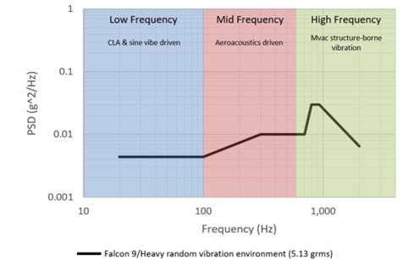

Figure 16: Different frequency category graph

These environments are within most general component qualifications due to practices such as GEVs or SMC-S-016. For highly sensitive components, extra acoustic testing should be conducted to assess if it would envelop the random vibration environment. This can be done by measuring acceleration responses near such components during acoustic testing. Components with high surface area to mass ratios will be most subject to higher acoustic excitation and should be noted as high interest areas during testing. The following table shows the maximum predicted environment at the given frequency of vibration.

Table 58: Falcon 9 Vibration Data

|  |  |
| --- | --- |
| **Frequency** | **Falcon 9/Heavy Payload Vibration MPE, (P95/50), 5.13 GRMS** |
| 20 | 0.0044 |
| 100 | 0.0044 |
| 300 | 0.01 |
| 700 | 0.01 |
| 800 | 0.03 |
| 925 | 0.03 |
| 2000 | 0.00644 |
| **GRMS** | **5.13** |

To test the spacecraft, it will be placed on a large shake table connected via the payload interface. The shaker can run through various testing modes such as sine sweeps, random inputs, and transient inputs.

## C. Acoustic Testing

During the flight, there are varying acoustic environment conditions that can affect the spacecraft. The highest acoustical loads are expected during liftoff and during transonic flight. Some important considerations when determining the acoustic loads the spacecraft will experience include payload size and payload volume. Acoustic loads can also be affected if acoustic blankets are used. Figure 17 and Figure 18 display third octave payload acoustic frequencies in Cape Canaveral and Vandenberg.

, Picture

Figure 17: Third octave payload acoustic data graph

, Picture

Figure 18: Third octave payload acoustic without the use of an acoustic blanket data graph

The solid line displays the results from the Cape Canaveral launch site and the dashed line displays the results from the Vandenberg launch site. Figure 17 and Figure 18 display that acoustic loads are decreased with the use of an acoustic blanket. The numerical data values presented in Figure 17 and Figure 18 are shown in Table 59 and Table 60.

Table 59. Third Octave Payload Acoustic Data

|  |  |  |
| --- | --- | --- |
| **Frequency (Hz)** | **Cape Canaveral Acoustic Limit Levels (P95/50), 60% Fill-Factor (Third-Octave)** | **Vandenberg Acoustic Limit Levels (P95/50), 60% Fill-Factor (Third-Octave)** |
| 31.5 | 118 | 119.75 |
| 40 | 119.5 | 120 |
| 50 | 120 | 120 |
| 63 | 120 | 120 |
| 80 | 119.8 | 119.8 |
| 100 | 120.5 | 120.5 |
| 125 | 121.5 | 121.5 |
| 160 | 122 | 122 |
| 200 | 121.5 | 121.5 |
| 250 | 120.5 | 120.5 |
| 315 | 119 | 119 |
| 400 | 117 | 117 |
| 500 | 115 | 115 |
| 630 | 113 | 113 |
| 800 | 111 | 111 |
| 1000 | 109.5 | 109.5 |
| 1250 | 108 | 108 |
| 1600 | 107 | 107 |
| 2000 | 106 | 106 |
| 2500 | 105 | 105 |
| 3150 | 104 | 104 |
| 4000 | 103 | 103 |
| 5000 | 102 | 102 |
| 6300 | 101 | 101 |
| 8000 | 100 | 100 |
| 10000 | 99 | 99 |
| **OASPL (dB)** | **131.3** | **131.4** |

Table 60. Third Octave Payload Acoustic Without the Use of an Acoustic Blanket Data

|  |  |  |
| --- | --- | --- |
| **Frequency (Hz)** | **Cape Canaveral Acoustic Limit Levels (P95/50), 60% Fill-Factor (Third-Octave)** | **Vandenberg Acoustic Limit Levels (P95/50), 60% Fill-Factor (Third-Octave)** |
| 31.5 | 118 | 120.5 |
| 40 | 119.5 | 121.5 |
| 50 | 120 | 122 |
| 63 | 120 | 122.5 |
| 80 | 121 | 123.5 |
| 100 | 123.3 | 124.5 |
| 125 | 127.7 | 127.7 |
| 160 | 129.3 | 129.3 |
| 200 | 129.8 | 129.8 |
| 250 | 129.5 | 129.5 |
| 315 | 128 | 128 |
| 400 | 126 | 126 |
| 500 | 124 | 124 |
| 630 | 122 | 122 |
| 800 | 119.5 | 119.5 |
| 1000 | 117.8 | 117.8 |
| 1250 | 116.4 | 116.4 |
| 1600 | 114.5 | 114.5 |
| 2000 | 113 | 113 |
| 2500 | 111.2 | 111.2 |
| 3150 | 110.2 | 110.2 |
| 4000 | 109 | 109 |
| 5000 | 107.5 | 107.5 |
| 6300 | 106 | 106 |
| 8000 | 104 | 104 |
| 10000 | 102 | 102 |
| **OASPL (dB)** | **137.6** | **137.9** |

Figure 19 and Figure 20 display the trends of full octave payload acoustic MPEs at full octave at both the Cape Canaveral launching site and Vandenberg launching site.

, Picture

Figure 19: Full octave payload acoustic data graph

, Picture

Figure 20: Full octave payload acoustic without the use of an acoustic data blanket graph

The solid line displays the results from the Cape Canaveral launch site and the dashed line displays the results from the Vandenberg launch site. Figure 19 and Figure 20 display that acoustic loads are decreased with the use of an acoustic blanket. This numerical data values presented in Figure 19 and Figure 20 are shown in Table 61 and Table 62.

Table 61: Full Octave Payload Acoustic Data

|  |  |  |
| --- | --- | --- |
| **Frequency (Hz)** | **Cape Canaveral Acoustic Limit Levels (P95/50), 60% Fill-Factor (Full Octave)** | **Vanderberg Acoustic Limit Levels (P95/50), 60% Fill-Factor (Full Octave)** |
| 31.5 | 122.4 | 124.1 |
| 63 | 124.7 | 124.7 |
| 125 | 126.1 | 126.1 |
| 250 | 125.2 | 125.2 |
| 500 | 120.1 | 120.1 |
| 1000 | 114.4 | 114.4 |
| 2000 | 110.8 | 110.8 |
| 4000 | 107.8 | 107.8 |
| 8000 | 104.8 | 104.8 |
| OASPL (dB) | **131.4** | **131.6** |

Table 62: Full Octave Payload Acoustic Without the Use of an Acoustic Blanket Data

|  |  |  |
| --- | --- | --- |
| **Frequency (Hz)** | **Cape Canaveral Acoustic Limit Levels (P95/50), 60% Fill-Factor (Full Octave)** | **Vanderberg Acoustic Limit Levels (P95/50), 60% Fill-Factor (Full Octave)** |
| 31.5 | 122.4 | 125.2 |
| 63 | 125.1 | 127.5 |
| 125 | 132.2 | 132.4 |
| 250 | 133.9 | 133.9 |
| 500 | 129.1 | 129.1 |
| 1000 | 122.9 | 122.9 |
| 2000 | 117.9 | 117.9 |
| 4000 | 113.8 | 113.8 |
| 8000 | 109.1 | 109.1 |
| OASPL (dB) | 137.6 | 137.9 |

## D. Shock Survivability

Shock is caused by four different causes. These causes are listed below.

1. Release of the launch vehicle hold-down at liftoff
2. Stage separation
3. Fairing deployment
4. Spacecraft separation

Out of these four major causes of shock during flight, the two most notable that will impact our upper bound of necessary shock resistance are the fairing deployment and the spacecraft separation. This is due to the large distance and number of joints that the shock will travel over to dissipate. The payload adapter and separation system will receive most of the stress and will be the main target area of testing to ensure no payload damage will take place.

Table 63: Shock Response Data

|  |  |
| --- | --- |
| **Frequency (Hz)** | **SRS (g)** |
| 100 | 30 |
| 1000 | 1000 |
| 10000 | 1000 |

The data in Table 63 is obtained by SpaceX and assumes a standard separation place P95/50, where SRS refers to the shock response spectrum and frequency is the rate of vibration.

## E. Shock Survivability

The four major causes of shock during flight are shown below.

1. Release of the launch vehicle hold-down at liftoff.
2. Stage separation
3. Fairing deployment
4. Spacecraft separation

Out of these four major causes of shock during flight, the two most notable that will impact our upper bound of necessary shock resistance are the fairing deployment and the spacecraft separation. This is due to the large distance and number of joints that the shock will have to travel over to dissipate. The payload adapter and separation system will receive most of the stress and will be the main target area of testing to ensure no payload damage will take place.

Table 64: Shock Response Data

|  |  |
| --- | --- |
| **Frequency (Hz)** | **SRS (g)** |
| 100 | 30 |
| 1000 | 1000 |
| 10000 | 1000 |

This is the data obtained by SpaceX assuming a standard separation plane P95/50, where SRS refers to the shock response spectrum and frequency is the rate of vibration.

## F. Testing

Once the spacecraft is initially built, the first test the spacecraft will undergo is environmental testing, including thermal vacuum tests to reproduce variations in temperature experienced in space. For these tests, the maximum temperature that will be experienced by the spacecraft during launch is 355 K. To uphold a 20% tolerance, our maximum temperature during testing should be 426 K. The lowest temperature our spacecraft will experience is 271 K during transit to Mars. To uphold the same tolerance, we will test temperatures down to 216 K. This will test the efficiency and longevity of the spacecraft itself as well as the insulation and ventilation systems for component temperature control.

Vibration testing will be performed by placing the spacecraft into a vibrating chamber, allowing the spacecraft to experience shaking. Along with vibration testing, shock testing will be performed to simulate the sudden shocks that a satellite may experience when being deployed from the launcher. The focus of this testing will be the payload adapter and separation system. This testing will ensure that at primary lateral frequency of 8 Hz, primary axial frequency of 20 Hz, and all secondary structure minimum resonant frequencies above 28 Hz, the spacecraft will maintain its structural integrity with a 20% tolerance. At lower frequencies, CLA and sine vibe driven will be observed, while at mid-frequencies, aeroacoustics driven will be analyzed. For high frequencies, MVac structure-borne vibration will be the testing focus.

Shock testing will also be performed with vibrational testing. The components of interest for this test include the payload adapter and the separation system. For a frequency of 100 Hz, the shock response spectrum is 30 g, for a frequency of 1000 Hz, the shock response is 1000 g. The same shock response from a 1000 Hz frequency is expected for the 10000 Hz frequency.

For acoustic testing, the spacecraft will be placed in a reverberating chamber and will simulate noise it would experience during launch. This test will be completed with an acoustic blanket to reduce the acoustic effects on the spacecraft. These noises would include internal sources such as engine operation and equipment. This would also include the structural vibration of the spacecraft. The main components focused on this test will be the components with high surface area to mass ratios. For the third-octave payload acoustic, the highest acoustic limit level is 122 dB at 160 Hz. For the full octave payload acoustic, the highest acoustic limit level is 126.1 dB at 125 Hz.

In addition, sinusoidal vibration testing will be performed to simulate the low-frequency launch environment the spacecraft will experience to verify that structural integrity is withheld.

Finally, the electrical components will be tested again to make sure all the electrical signals are sent and received as they should be after the previous tests. This will also include checking the software, navigation and pointing equipment, along with all operating nodes. These components will be evaluated again by performing the same temperature evaluation test that was described earlier in this section.

To limit travel, possible travel damage to the spacecraft, high costs, and to keep the mission on schedule, the spacecraft will be tested at Kennedy Space Center Launch Equipment Test Facility (LETF) in Merrit Island, Florida. This facility offers a multitude of tests that fit these requirements, including but not limited to vehicle motion simulation testing, energy absorption testing, ELV payload fairing testing, and LN2 & LH2 cryogenic testing. Other tests available at this facility are listed below in Figure 21.

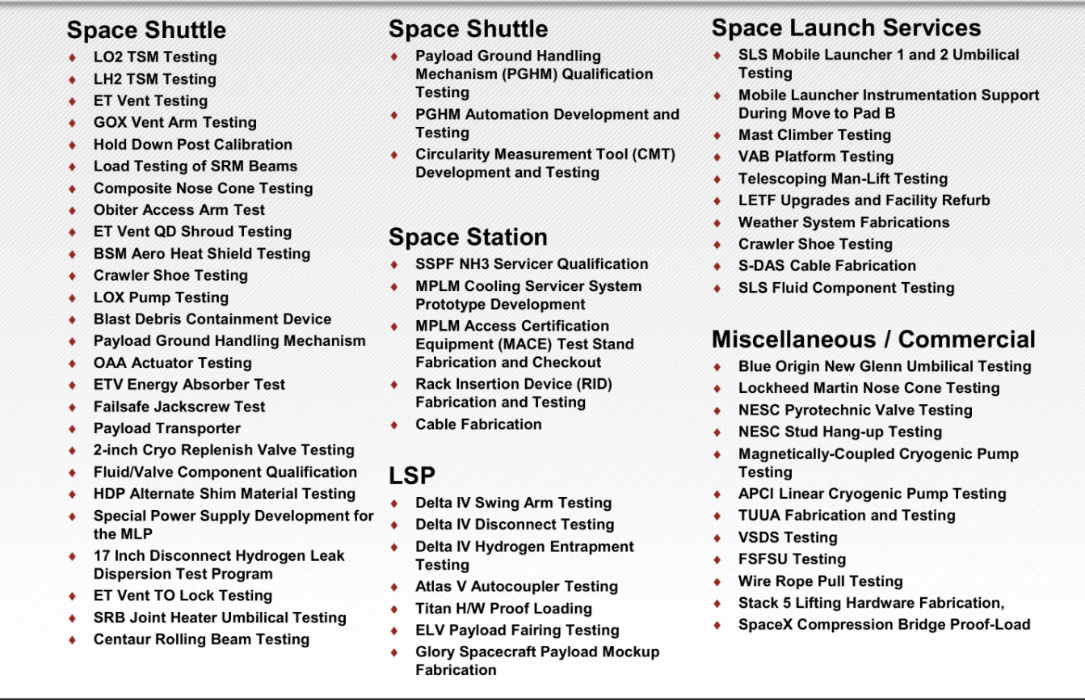

Figure 21: Services offered at Kennedy Space Center

# Insurance

AXA XL will be used to provide insurance for pre-launch, launch, in-orbit, and liability coverage for spacecraft and launch vehicles.

AXA XL is commonly used for small launch satellites and launch vehicles, unique mission designs, and new technology and applications.

# Acknowledgements

The OrbitLink team would like to thank the following members for their contributions to this project and mission report: Colin Berg, Craig Dedrick III, Liya Elan, Serena Elijah, and Stephanie Ramsey. This project would not have been possible without each member of this team, as each person provided a different perspective and brought different skills that allowed this mission design to be possible.

In addition, thank you to our professor, Dr. Jennifer Smith, and our teaching assistant, Matthew Willoughby, for assisting with the completion of this project. Dr. Jennifer Smith provided insightful knowledge from her past work experience and assisted with the completion of specific project milestones. Matthew Willoughby answered all questions we asked to the best of his ability and helped the development of this project to be a success.

The OrbitLink team would also like to thank our classmates for helping with solving complex problems that were encountered, along with learning how to design a spacecraft from start to finish.

Thank you to Dr. Thomas Lovell for assisting with the completion of the Interface Control Document and the block diagrams.

# References

1. AAC Clyde Space. (2024, March 13). *MTQ800 - Satellite Magnetorquers | AAC Clyde Space*.

https://www.aac-clyde.space/what-we-do/space-products-components/adcs/mtq800-10

1. AAC Clyde Space & Berlin Space Technologies. (2021). *ST400 STAR TRACKER* [Technical Report].

https://www.aac-clyde.space/wp-content/uploads/2021/11/ST400.pdf

1. AAC Hyperion & Berlin Space Technologies. (2023). *ST200 Star Tracker* [Technical specifications].

https://www.aac-clyde.space/wp-content/uploads/2021/11/ST200-1.pdf

1. Andreis, E., Panicucci, P., & Topputo, F. (2024). Autonomous Vision-Based algorithm for interplanetary navigation. *Journal of Guidance Control and Dynamics*, *47*(9), 1792–1807.
2. Biertümpfel, F., Pfifer, H., & Theis, J. (2024). Robust Space Launcher Control with Time-Varying Objectives. *Journal of Guidance Control and Dynamics*, *47*(5), 934–944.

https://doi.org/10.2514/1.g007632

1. Blue Canyon Technologies. (2025). *Blue Canyon Reaction Wheels Product Description*.

https://www.bluecanyontech.com/wp-content/uploads/Reaction-Wheels-1_2025.pdf

1. Blue wave miniature spectrometers. (n.d.-b). https://www.stellarnet.us/spectrometers/blue-wave-miniature- spectrometers/
2. Bruzzi, J. R., et al. (2012). A compact laser altimeter for spacecraft landing applications. *JOHNS HOPKINS APL TECHNICAL DIGEST*, *30*(4), 331–333.

https://secwww.jhuapl.edu/techdigest/Content/techdigest/pdf/V30-N04/30-4-Bruzzi.pdf

1. C14 Bi-axis gimbal. (n.d.-c). https://www.sierraspace.com/wp-content/uploads/2024/01/POINTING- SYSTEMS-AND-MOTION-CONTROL-C14-Bi-Axis-Gimbal.pdf
2. Cinescopophilia. (2017, January 3). *Panasonic DMC FZ-2500 Review Test Shots 4K from Cars And Cameras*. Cinescopophilia.

https://cinescopophilia.com/panasonic-dmc-fz-2500-review-test-shots-4k-cars-cameras/

1. *DASH - Servo Corporation of America | Earth/Horizon Sensor*. (n.d.).

https://www.satnow.com/products/earth-horizon-sensors/servo-corporation-of-america/44-1240-dash

1. E3s-conferences. (n.d.-d). https://www.e3s- conferences.org/articles/e3sconf/pdf/2017/04/e3sconf_espc2017_13004.pdf
2. Edwards , C. D., Jr (2003). *The Electra Proximity Link Payload for Mars Relay Telecommunications and Navigation*. AIAA arc.

https://arc.aiaa.org/doi/epdf/10.2514/6.IAC-03-Q.3.a.06

1. Gomez-Ros, J. M., Jr., Bedogni, R., Moraleda, M., Delgado, A., Romero, A., Esposito, A., & ELSE NUCLEAR Srl. (2024). Spectrometric performance equivalent to a 6-unit BSS. In *SINGLE- SPHERE NEUTRON SPECTROMETER* (Vol. 613, pp. 127–133) [Journal-article].

http://www.elsenuclear.com/media/k2/attachments/DAT_SP2_EN_1.07.pdf

1. Hasha, M. D. & Lockheed Martin Space Systems Company. (2016). High-Performance Reaction Wheel Optimization for Fine-Pointing Space Platforms: Minimizing Induced Vibration Effects on Jitter Performance plus Lessons Learned from Hubble Space Telescope for Current and Future Spacecraft Applications. In *Proceedings of the 43rd Aerospace Mechanisms Symposium*.

https://ntrs.nasa.gov/api/citations/20160008147/downloads/20160008147.pdf

1. Hsu, D. K. (2014, March 27). *Non-destructive evaluation (NDE) of Aerospace Composites: Ultrasonic Techniques*. Non-Destructive Evaluation (NDE) of Polymer Matrix Composites. https://www.sciencedirect.com/science/article/pii/B9780857093448500154
2. IEEE Xplore. (n.d.-h). https://ieeexplore.ieee.org/Xplore/home.jsp
3. Intel Corporation. (n.d.). *What is the maximum operating temperature of my Intel® processor?* Intel.

https://www.intel.com/content/www/us/en/support/articles/000094759/processors.html

1. *Intel® Xeon® Gold 6248 processor (27.5M cache, 2.50 GHz)*. (n.d.). Intel.

https://www.intel.com/content/www/us/en/products/sku/192446/intel-xeon-gold-6248-processor-27-5m-cache-2-50-ghz/specifications.html

1. JHUAPL. (n.d.-g). https://secwww.jhuapl.edu/techdigest/content/techdigest/pdf/V17-N02/17-02- Mobley.pdf
2. *K508 - Ricor*. (2022, June 22). Ricor.

https://ricor.com/products/k508/

1. L3Harris Technologies, Inc. (2022). *ARIES-25 SENSOR SYSTEM* [Report].

https://www.l3harris.com/sites/default/files/2022-04/L3Harris_Aries-25_SellSheet_2022_Rev%20A.pdf

1. *Lunar Lander uses laser velocity and ranging | Advanced navigation*. (2025, February 6). Advanced Navigation.

https://www.advancednavigation.com/case-studies/intuitive-machines-looks-to-advanced- navigation-laser-velocity-and-ranging-technology-for-autonomous-commercial-lunar-landings/

1. Mahaffy, P. R., Benna, M., King, T., Harpold, D. N., Arvey, R., Barciniak, M., Bendt, M., Carrigan, D., Errigo, T., Holmes, V., Johnson, C. S., Kellogg, J., Kimvilakani, P., Lefavor, M., Hengemihle, J., Jaeger, F., Lyness, E., Maurer, J., Melak, A., . . . Nolan, J. T. (2014b). The neutral gas and ion mass spectrometer on the Mars Atmosphere and Volatile Evolution Mission. *Space Science Reviews*, *195*(1–4), 49–73.

https://doi.org/10.1007/s11214-014-0091-1

1. MEISEI ELECTRIC CO., LTD. (2020). *Features*.

https://www.meisei.co.jp/english/wp-content/uploads/2020/07/3-Axis-Magnetometer-for-small- Satellite.pdf

1. Moog Inc. (n.d.). *High Power Type 5-TC Solar Array Drive assembly*.

https://www.moog.com/products/space-mechanisms/solar-array-drive-assemblies/high-power-type-5-tc.html

1. NASA. (n.d.-l). https://ntrs.nasa.gov/api/citations/20190032191/downloads/20190032191.pdf
2. NASA. (n.d.-b). *NASA Technical Reports Server (NTRS)*. NASA. https://ntrs.nasa.gov/
3. N A S A, Hall, J. M., Harris, M., Exotech, Inc., NASA Electronics Research Center, NASA Headquarters, Adcole Company, Ball Brothers Research Corp., TRW Systems, Honeywell Radiation Center, Harvard College Observatory, Jet Propulsion Laboratory, Naval Research Laboratory, MIT Lincoln Laboratory, Bendix Corp., NASA Ames Research Center, Stanford University and Kitt Peak, NASA Marshall Space Flight Center, NASA Goddard Space Flight Center, & National Observatory. (1970). *SPACE VEHICLE DESIGN CRITERIA [GUIDANCE AND CONTROL] NASA SP-8047 SPACECRAFT SUN SENSORS*.

https://ntrs.nasa.gov/api/citations/19710008281/downloads/19710008281.pdf

1. *NOVA-C | Intuitive Machines*. (n.d.). Intuitive Machines.

https://www.intuitivemachines.com/nova-c

1. Redwire Corporation. (2021). *Roll out Solar Array (ROSA)*.

https://redwirespace.com/wp-content/uploads/2023/06/redwire-roll-out-solar-array-flysheet.pdf

1. Safran, Navigation and Timing. (2025, March 12). *Rubidium Atomic Clocks and Oscillators - Safran - Navigation & Timing*. Safran - Navigation & Timing.

https://safran-navigation-timing.com/solution/atomic-clocks-and-oscillators/

1. Silicon Sensing. (2025, January 15). *CRS43 robust gyroscope sensor | Silicon Sensing*.

https://siliconsensing.com/product/crs43

1. Sierra Space. (2025, February 13). *Sierra Space | Commercial Space and Defense Technologies*.

https://www.sierraspace.com/

1. Snoeys, W. (2007, September 2). *CMOS monolithic active pixel sensors for high energy physics*. ScienceDirect. https://www.sciencedirect.com/science/article/abs/pii/S1380732398800046
2. *Space insurance*. (2025, March 25).

https://axaxl.com/insurance/products/space-insurance

1. *Spaceflight cryocoolers*. (n.d.).

https://www.sunpowerinc.com/products/stirling-cryocoolers/cryotel-cryocoolers/spacecryocoolers

1. *ST200 - AAC Clyde Space | Star Tracker*. (n.d.).

https://www.satnow.com/products/star-trackers/aac-clyde-space/37-1154-st200

1. Sun Sensor on a chip (SSOC-A60) - Technical specification, Interfaces & Operation. (2015). In *Technical Specification, Interfaces & Operation* (pp. 1–15). Solar MEMS Technologies.
2. *Thermal Control - NASA*. (n.d.). NASA.

https://www.nasa.gov/smallsat-institute/sst-soa/thermal-control/#7.3.1

1. Wrangler, V. (2016, March 4). *Ultra-Small Super Hi-Vision 8K Developed Cube Camera Head from NHK:* Cinescopophilia.

https://cinescopophilia.com/ultra-small-super-hi-vision-8k-developed-cube-camera-head-from-nhk/

1. Zakrajsek, J. J., McKissock, D. B., Woytach, J. M., Zakrajsek, J. F., Oswald, F. B., McEntire, K. J., Hill, G. M., Abel, P., Eichenberg, D. J., Thomas W. Goodnight, & NASA Glenn Research Center. (2005). Exploration Rover concepts and development challenges. In *First AIAA Space Exploration Conference*.

https://www.nasa.gov/wp-content/uploads/2015/06/exploration_rover_concepts_grc.pdf

1. Gomez-Ros, J. M., Jr., Bedogni, R., Moraleda, M., Delgado, A., Romero, A., Esposito, A., & ELSE NUCLEAR Srl. (2024). Spectrometric performance equivalent to a 6-unit BSS. In *SINGLE- SPHERE NEUTRON SPECTROMETER* (Vol. 613, pp. 127–133) [Journal-article].